Mobile Enterprise Application Architecture Guidance for
Remote Communications in an Occasionally-Connected World
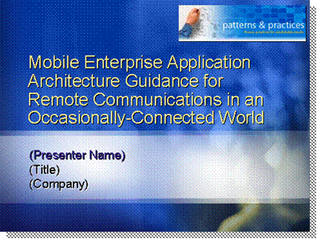
*****************************illegal for non-trainer use******************************
Start with your own personal introduction, and then move on to the preamble.
Introduction
Enterprise applications have long been accessible to office users and knowledge workers in various ways. Whether they are deployed locally as rich clients or accessed centrally as Web clients running within a browser, enterprise applications connect people, systems, processes and data in order to achieve enterprise agility. This is done by relying on systems that enhance productivity, lower operational costs, and enable new ways to work with our data, resulting in a competitive advantage.
Preamble
Great technological advances in the field of mobility have allowed us to reach even farther out, beyond the physical boundaries of the enterprise. Faster wireless networks, broader coverage, more powerful devices, different form factors and state of the art development tools have all contributed to the mobile revolution currently in progress.
Users that have been long forgotten by the world of information technology are now able to participate in automated business processes once again. Both internal and external mobile and field workers can access corporate data from the road, alter it or collect new data, and submit it back to the central office.
Spurred by technologies like the Microsoft® .NET Compact Framework, which brings managed code and Web services to mobile devices, a new breed of “smart” client applications is emerging and changing the way we think about software development. These new smart clients are based on best practices learned by merging rich clients and Web development, bringing the best of both worlds to the realm of mobile devices.
This presentation covers enterprise applications and how they can be extended to support the use of mobile devices. It is important to note that mobile clients should not be treated entirely differently than from regular desktop or laptop-based smart clients. Bandwidth, connectivity, security, storage and memory considerations are important to factor in the architecture, but standard architecture principles can be reused when applied in mobility scenarios.
Remote Communications in an Occasionally-Connected World
More specifically, you will learn about many of the different ways to leverage the intermittent connectivity you have available on a mobile device. Mobile devices aren't always on the Web or docked into the corporate network. Therefore your applications have to handle a range of scenarios for transferring data to and from the home office during times when a connection is available and storing information locally when a connection is not available.

Make sure you connect with the students’ knowledge of distributed systems and allow them to identify with common existing scenarios they are familiar with in order to bring them to the point where they can embrace mobility without seeing it as a completely new paradigm.
Note

The following roles consist of the primary audience for this session:
Intended audience
- Software architects
- Enterprise solution architects
- Mobile solution architects
- Project lead developers
The topics discussed are also relevant for the following roles in the enterprise:
- Software and enterprise developers
- Mobile device application developers
- Mobile application project managers
- IT infrastructure architects (especially if they will be involved in the infrastructure planning and deployment for enterprise mobility projects)

It is important that you make sure that expectations are clear about the objective of this presentation and the intended audience. This is a session for software and solution architects, and as such will focus more on design, architecture best practices and patterns. It is highly likely that you will have attendees who are more development-focused, expecting to learn about coding techniques and see developer demos. Make sure you frame the topic properly and emphasize the importance of the content even for developers who might or might not be aware of the architecture challenges that are faced in enterprise mobility projects.
Important

Agenda

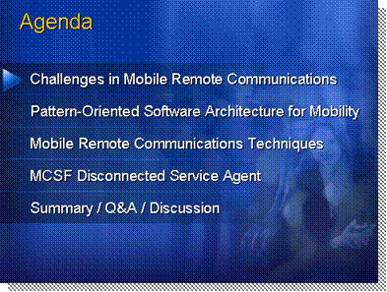
*****************************illegal for non-trainer use******************************
This session looks at the Disconnected Service Agent Application Block, which provides management features for execution of Web services from occasionally connected mobile devices. But first, we need to explore the challenges it addresses and what other remote communication alternatives developers can use.
Agenda
This presentation covers the following topics:
Presentation Agenda
This first topic covers the various challenges mobile developers face and focuses mainly on the management of network connectivity from within managed applications. Make sure to remind students that the switch from online to offline mode should be transparent to the user and that a smart client needs to determine what action to take when it comes to data storage and retrieval depending on whether or not a connection to the network is available. We’ll discuss a sample architecture, present the overview of mobile enterprise applications and cover the main precepts of occasionally-connected computing and how network-awareness affects your designs.
Challenges in Mobile Remote Communications
Next we’ll explore the use of design and architecture patterns in mobility scenarios. This is mainly a review of the role of patterns as seen in the Overview session. The patterns are not reviewed individually but we are rather focusing only on their role and how they fit in the world of mobility and how they affect design and architecture. We’ll then discuss synchronous and asynchronous operations as they pertain to remote communications.
Patterns-Oriented Software Architecture for Mobility
In this section, we’ll go through an inventory of the various techniques you can use to communicate between mobile devices and servers. We’ll talk about mobile applications that use a data access layer to communicate directly with the central database instead of caching it locally. Explain how this is better suited for scenarios where connectivity can be reliable and stable, like Wi-Fi, and where chances of data conflicts are high in an environment where data changes rapidly. We’ll also cover the other side of data access where relational enterprise data gets cached locally on the device and then synchronized back with the server when connectivity is reestablished. Make sure students understand the pros and cons of both RDA and merge replication as the former might be easier to use but also provides the lowest amount of control over replication.
Mobile Remote Communications Techniques
Then this topic covers messaging in general from mobile devices, more specifically message queuing. Make sure you explain the conundrum of unreliable networks in mobility versus the need for guaranteed messaging in the enterprise. We’ll follow with an introduction to Message Queuing and the concept of asynchronous operations. Verify that the students understand that asynchronous operation means that more than one operation can be executed simultaneously. Be sure that students also understand that Message Queuing is a technology that implements message queuing in an application. This preceding point is important because most applications are either enterprise-level applications or Web applications. Both of these types of applications must be scalable. Tell students that the key characteristic of a scalable application is that an additional load only requires additional resources, rather than requiring extensive modification of the application itself. This is why Message Queuing is so valuable.
Lastly we’ll discuss Web services and calling them from mobile clients. Most of these principles should already be familiar with your audience so take the opportunity to explain the key role of Web services as a high level remoting technology that can be used to connect the mobile client tier and the server tier.
We will then quickly review the Mobile Client Software Factory (MCSF) by patterns & practices and what application blocks are and which ones are provided in the Mobile Client Software Factory to assist in designing solutions based on mobile smart clients. The rest of the discussion will then focus on how to architect solutions using the MCSF Disconnected Service Agent. Again, this is not a developer discussion so make sure you present the application blocks in a light that is relevant to design and architecture, and not from a coding point of view. However, it is important that architects understand how the developers on their team will use these application blocks to implement the model defined in the mobile solution architecture.
Mobile Client Software Factory Application Blocks Overview
You can announce that questions will be taken at the end after the summary, and that the floor will be open for a discussion on the topics covered. Be very careful before you decide to field questions along the way. Be mindful of the allotted time you have and remember that discussions around design and architecture often have a tendency to turn into debates. This is why it is recommended that you wait until the end and until all the material has been presented before taking questions from attendees. As an alternative, you can allow a couple of minutes at the end of each section to answer 1-2 immediate questions and make sure attendees are following the content well enough to continue. Simply defer open ended questions and debates until the end.
Summary / Q&A / Discussion

Mobile Application Development Challenges

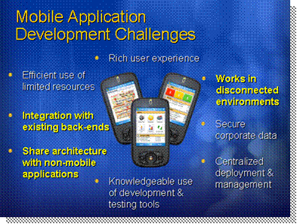
*****************************illegal for non-trainer use******************************
Architecture is all about choices: What model will you adopt? How will you reconcile the logical layers of the application with the physical tiers in deployment? Will you go with a Web-based or a smart client? Do you need clustering on the server-side? There are many more aspects you need to consider in any enterprise project:
Introduction
- What database technology to adopt and what will be your storage strategy
- Defining boundaries for components and services
- Which platforms and technologies to target
- What is the networking environment, and which protocols to use
- What threats need to be mitigated and which security strategy to adopt
- What transactional model is needed
- How to meet your scalability and availability numbers
- Addressing reliability, data integrity, and flexibility to grow
- Covering compatibility and interoperability with legacy systems and technologies
- Making the system manageable for administrators and insuring high usability for the workforce
- Meeting the needs of the business while still designing a system that is affordable, with a known total cost of ownership (TCO) and a reasonable return on investment (ROI)
While these questions, and many others, also apply to enterprise mobility scenarios as well, some key challenges arise when faced with applications running on devices in the field.
Mobile application development challenges
The key aspects we will focus on in this presentation are:
- Is the mobile application running standalone or integrated as part of an enterprise system? This session assumes the latter and covers the challenges and solutions architects need to be familiar with. This will typically mean that mobile applications will need to reach out to existing back-end and legacy systems, which can lead to complex integration strategies due to incompatible models and technologies.
- Communication strategy: Mobile applications will be disconnected from the rest of the enterprise or the Internet more often than they will be. Nationwide networks are expanding, but most rural areas still have spotty coverage at best, and even large metropolitan areas suffer from wireless holes, dropped connections, dead zones deep within buildings and overloaded networks due to high traffic at certain times. Network-awareness is critical to any mobile scenario as it should be the application, not the user, that needs to manage when it is connected, and when it is not.
Other important factors and considerations include:
- Target devices: Choosing the wrong device or form factor can spell the doom of your project on day 1. This topic is covered in the next slide.
- Feature set: Which features make sense in the field? What should be cut? How much can you, and should you, share with your non-mobile applications? This can apply to both the functionality list as well as the architecture itself of the system. The functionality in mobile applications may have to be streamlined and cut-down to the essentials, but providing a rich user experience is still a key part of your project’s success.
- Local data strategy: At which point do you drop XML files in favor of a local mobile database? 100 records? 10,000? The rules are not the same as the desktop as memory and processor cycles are not as abundant on devices.
- Device resources: Mobile devices do not sport GHz CPUs and gigabytes or RAM. Resources are limited and your applications need to make an efficient use of them. The battery is another such resource that is finite and the power management vs. performance equation has to be balanced in all aspects of the design. The more you use the CPU, the wireless radios or the screen/video for that matter, the faster your device battery will tank. But you still need to provide adequate performance to insure user acceptance and productivity gains.
- State management strategy: So what if the battery fails and the user was in the middle of a usage scenario? What happens to the transient state? Is it lost? Or was it persisted in non-volatile memory during every step of the scenario?
- Security: Securing corporate data has always been a high priority, but the moment that data leaves the premises and the boundaries of your office, it becomes at much higher risk. Which threats must you mitigate, and how? How can you secure data at the application, device, storage, and network level without crippling the usability of your application?
- Deployment: Pushing new applications and updates to rich clients on the desktop has always been a challenge in itself, but what do you do when the physical deployment device is not even connected to the network and out of the office most of the time? Web-based applications gained a lot of popularity thanks to centralized management and deployment, but when connectivity cannot be taken for granted in the field, the majority of mobile scenarios have to adopt a smart client deployment model.
- Location awareness: Where is the user? Track the device, and you have found him or her. The users themselves often need to be aware of their work environment. Unlike traditional corporate users sitting at their desk, the mobile user needs to know where the assets they deal with are located, how to get there, what can interfere, will traffic delay their schedule, and so on. Bridging mobile applications and location intelligence is a natural fit, but it can also introduce more challenges such as location technologies (GPS, cellular, etc.), storing massive amounts of location data vs. accessing it over wireless, hurting battery life even further, etc.
- Technology platform: There are already many technologies, platforms and languages the enterprise developer has to master, adding new ones for mobility can cause more problems than it fixes. Do enterprise developers need to learn new tools and techniques for mobile development, or can they reuse some knowledge of their favorite programming models and languages and tools? And if mobile applications are run on different machines (i.e. devices) than they are developed (i.e. desktop), how can you properly test them in a productive and efficient way?
Smart clients are the wave of the future when it comes to user interface design and implementation. Rich clients have always excelled at providing a rich user experience with local access to validation and business logic, advanced user controls and the best way to present data to the user and allow them to manipulate it in any way, shape or form. Web clients were introduced as an alternative to rich clients by compensating for obvious deficiencies like deployment and maintenance. The drawback is that Web clients are still more limited when it comes to the user experience and development costs are still higher due to the inherent shortcomings of HTML. Web clients also need constant connectivity, which makes them undesirable for mobility scenarios.
Smart Clients and mobility
Smart clients address this conundrum by bringing the best of both worlds, Windows and Web, into a new form of rich client. These rich clients offer the same user experience richness you can expect from Windows-based clients but extend them with functionality normally found in Web clients, as well as additional “smart” features that extend their functionality based on their distributed nature. Smart clients rely on local resources in order to provide the most power to the user, which is something a Web client cannot do.
Smart Clients are Rich Clients with Smart Features
One such “smart” feature is the ability of a smart client to automatically deploy itself without requiring setup kits and manual or scripted deployments. Web clients have always been popular thanks to the centralized nature of the application on the Web server where no client deployment is needed. Smart client reuse this model by living inside a Web server as well, ready to be initiated. When first accessed by a new user/client, the smart client downloads itself to the client machine or device along with all its dependencies, therefore eliminating the need for a local installation before the application can be used. Technologies like ClickOnce in .NET Framework 2.0 can provide such functionality for desktop scenarios, but unfortunately not for mobile device applications. Mobile smart clients typically need to be deployed to the device first, and then a bootstrapper can manage updates as they become available on the deployment server.
Deployment
By the same token automated deployment features can also make sure the latest version of all assemblies are always available on the client device. Whereas the application downloads the required dependencies on first use, future updates posted on the central Web server are also detected the next time the application is used by comparing assembly dates, times and version numbers. Once it is identified that a newer version exists, a local bootstrapper downloads the new files, performs the proper configuration operations and then executes them. The end-user might notice a slower initialization routine whenever such updates are being processed, but the whole process is transparent and does not require any human interaction.
Maintenance and updates
Rich clients in client/server architectures may always be connected to the central server, just like Web clients always need to be connected to the central Web server, but distributed three-tiered systems do not always demand full-time connectivity. Sometimes that connectivity is not even available or you may want to preemptively prepare for the eventuality of potential connection drop in mission-critical systems. Or it may just be that the user is running the application on a laptop, Tablet PC or mobile device where 100% online access to the server is simply impossible. Since smart clients run locally, they can therefore run in offline mode. This means that smart clients need be aware of when they are online or offline and manage data access and user requests accordingly, such as relying on asynchronous invocation, store-and-forward messaging and local caching of snapshots of data.
Connectivity
Data is the central piece of all management systems, and smart clients excel at manipulating data. Because of the requirement for offline use, smart clients need to download snapshots of data from the central server before disconnecting from the network so the user can keep on working on the road. The user might then gather more data, enter new records, update existing fields in the local data, resulting in the local database being out of sync with the central database. The company might have several users working in such a disconnected scenario as well, and when these users later reconnect with the network, all these changes need to be synchronized back with the central database or repository. Potential conflicts need to be resolved as they occur and this needs to be done automatically without requiring user involvement.
Data management
Finally, users simply want to use the system, without having to be aware of connectivity, caching or data management issues. A good smart client needs to be able to shield the end user from the complexities of disconnected scenarios and data synchronization and provide a user experience that is as seamless and transparent as is possible. This means that it should be able to switch from synchronous to asynchronous calls when needed, use the central database or local data snapshot depending on which is available, resolve conflicts based on predetermined rules instead of user input, and the likes. This is where a rich client truly becomes “smart” by understanding the context within which the end user is working and adapting the user interface and logic accordingly.
Ease of use

The Microsoft .NET Framework 2.0 provides several technologies, namespaces, classes and application blocks to enable smart client functionality, such as the Smart Client Offline Application Block, the Enterprise Library Application Block and ClickOnce deployment. Unfortunately many of these features and technologies are not yet available for the .NET Compact Framework 2.0, which means developers have to implement their own designs in mobile smart clients to emulate some of these missing features. This results in a lesser level of standardization but is nonetheless critical for the success of mobile smart clients. However, as will be covered later, the Mobile Client Software Factory does provide many essential application blocks that prove invaluable in designing and implementing mobile smart clients. As for the missing namespaces in .NET Compact Framework, a partial alternative for some of them can be found in the Smart Device Framework library of managed classes and controls from OpenNETCF.org, and also in other third party packages for .NET Compact Framework. The Windows Mobile 5.0 SDK also provides mobile developers with many new managed APIs they can leverage to write device-specific code.
Important

Sample Application Architecture

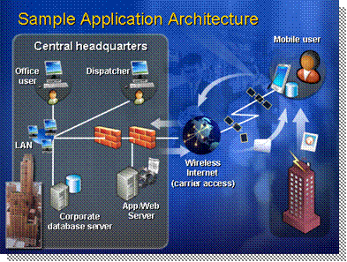
*****************************illegal for non-trainer use******************************
Mobile applications typically plug-in to the existing enterprise architecture of most companies. Application and database servers can be accessed remotely, whether you are located internally on the local intranet or accessing them over a wireless connection from a mobile device with Internet access. This sample architecture shows such a scenario for a company that needs to support mobile inspectors in the field.
Introduction
In this example, mobile inspectors carry a Windows Mobile Pocket PC device and drive from location to location to assess the state of field structures, like bridges, tunnels, sidewalks, pillars, etc. The mobile application contains a mobile database with all the structure details, such as inspection history, structure attributes, what needs to be inspected, and even digital photos. Inspection information is captured directly in the device and stored in the local mobile database.
Field workers
Once the inspection is complete, the user can upload the new or edited data back to the server. This could be done through a variety of remoting techniques like Web services or data synchronization, and most of these techniques are discussed later. However, connectivity to the server might not always be available, as the wireless connection could be online or offline. The application needs to know this and behave accordingly, independent of the user requests. Connectivity integration should be transparent to the user. In any case, most of these communications will be done over HTTP, thus reusing the server-side Web infrastructure already in place at the central headquarters of the company.
Data upload and server connectivity
The typical daily routine of the mobile inspector is usually pre-planned in the form of a standard route that is downloaded from the server to the device. These routes can be prepared by the mobile inspectors themselves or by central dispatchers in charge of structure allocation. There are of courses cases where dispatchers need to alter the route of a mobile inspector by sending them an update in the middle of their day. For such a scenario, a “live push” infrastructure is required using mechanisms like e-mail, SMS messages, message queuing. Polling should be avoided as it creates extra traffic over the slow and costly wireless network and is also prone to draining the device battery faster.
Pushing live updates
Data is not always in text or XML format. Inspectors might elect to take a picture of a damaged structure using the built-in digital camera of the Pocket PC device. The photo files are stored locally and can then be linked with the inspection database data. Sending these pictures can add strain to the connection and cause massive updates to the server, which can block the responsiveness of the local mobile application. In cases like this, it becomes advantageous to adopt asynchronous mechanisms and calling server resources in the background maintain a high “perceived” performance.
Field photography
Scenarios like this one easily show how the same application needs to manage its communication with the server in various ways. Push vs. pull, synchronous vs. asynchronous, data replication vs. messages, these are all the questions that need answered while you design your mobile application architecture. Make sure you understand the use cases and what users will be doing in the field, and in which environment, before jumping to hasty conclusions when faced with a technological dilemma.
Use case driven design

Mobile Solution Architecture Overview
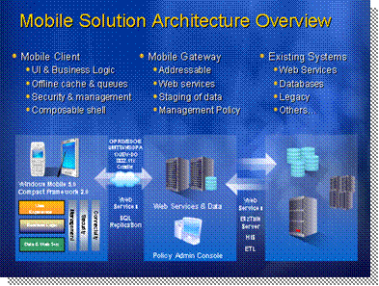
*****************************illegal for non-trainer use******************************
Most enterprise networks are already designed to support multiple types of clients that access central resources and applications remotely. Some of these clients are Web-based and communicate via Web servers while others are rich or smart clients and use a plethora of networking alternatives to reach out to the servers and back-end systems.
Introduction
Mobility does not require a new infrastructure, you can simply resuse the existing corporate architecture and extend it to support mobile clients running on devices and their various access and communication requirements. This typically starts with opening up the corporate network securely to the Internet if it has not already been done.
Reusing and extending the infrastructure for mobile clients
By exposing a public Web server running Internet Information Server (IIS) as the main mobile gateway to the corporate network, mobile devices can open secure Web connections over the wireless Internet to get authenticated and access existing systems from the field, directly or indirectly, such as back-end systems, application servers, legacy systems, databases and shared repositories. Web services are typically the preferred way of safely exposing corporate resources to the Internet but other alternatives are also available as detailed later in this lesson. Note that Web services can also be used between the mobile gateway and the rest of the enterprise when secure boundaries (like a DMZ for example) need to be crossed.
Mobility does not require a new infrastructure, just extend the existing one
When organizations consider mobile enterprise solutions, one key evaluation point is security. Pocket PCs can store large amounts of data and connect to a broad spectrum of networks, making them as important and sensitive a computing platform as laptop computers when it comes to an organization’s security plan. Mobility introduces more security risks. Portable computers and mobile devices all require special security due to their portability. Increasingly, users are connecting such devices to corporate networks or the Internet. Even if users do not store sensitive data on these devices, the devices often contain the user’s authentication information, which an attacker can exploit. Mobile devices are also often equipped with WLAN wireless network interfaces. Wireless connections, if not properly secured, are vulnerable to exploitation in public areas such as airports. These security risks and some of the techniques you can use to prevent against them are covered briefly later in this presentation.
Important

Mobile users cannot always be connected though. Constant wireless network connectivity from a device can be both expensive and battery consuming, and carrier-operated wireless WANs are not always fully reliable. Dead zones in the coverage, lack of carrier towers in certain rural areas, thick walls, elevator shafts, underground networks, sitting in a no-signal area in the middle of large office buildings, these are all valid scenarios that can force a mobile user into offline mode. Both online and offline access need to be supported, and proper asynchronous and offline caching mechanisms and queues need to be architected in the infrastructure.
Mobile clients for a mobile workforce
There are many reasons why mobile users need access to central corporate resources. The most common scenarios include:
- The ability to pull data from central databases and other back-end or legacy systems.
- Perform requests for specific contexts, such as customer files, client histories, technical manuals, searching knowledge bases, query orders for their current status.
- Get the latest snapshots of database tables for use in the field in offline mode.
- Submit field data to the server or send updates based on data pulled in snapshots earlier.
- Send status updates, digital signatures, digital photos
It’s also important to note that dedicated mobility services are preferable when dealing with mobile devices. While it can be tempting to reuse existing Web services or other service façades on the server, it is better to design new services that can in turn call the existing ones. These new “mobility-aware” services on the gateway can then filter data appropriately, control result sets in staging areas, and manage bandwidth to avoid sending too much data back to client devices where memory, storage and network connections are more limited.
Mobile users are more than just about wireless connections and devices. They also typically need the support of internal workers who coordinate their work and movements, such as dispatchers monitoring users in the field, tracking their location, sending important alerts and noteworthy notifications, job updates and the likes.
Interacting with field workers
These dispatchers and coordinators often only manage mobile users and do not have other responsibilities internally. They therefore require special applications to interact with the field, monitor data sent by mobile workers, send updates and alerts and manage their activities. For example, if a new job comes in and needs to be dispatched to a field worker, a central coordinator could decide to whom it should go based on expertise, current location and availability, and then assign the job to them, which results in a job alert being forwarded to the appropriate field worker.
Since mobile applications can work in both online and offline mode, they need to monitor the current connectivity status and switch modes based on the current context and network availability. When online, device applications should grab the opportunity to synchronize back with the server, forward data updates and captures, pull down new snapshots and look for job updates, while listening for live notifications. When offline, the same smart client applications need to cache all data captures and modifications, put requests and messages in a store-and-forward repository and maintain session state for the user in case the device battery runs out. All this should be done transparently from the user to limit human interactions as much as possible. The smart client is only truly successful if the user can barely see the difference between being online or offline.
Connectivity
This also means that server components need to understand that mobile devices are not always available, and if data, alerts and notifications need to be “pushed” to the field, asynchronous services need to be used since there is no guarantee that the user will be online when the update needs to be sent. Communication between the central office and mobile devices go both ways, pull and push, and all mechanisms need to take the following into consideration:
- Connectivity status of the mobile user/device.
- Type of device and configuration, including memory, storage space.
- Specific hardware specifications for the devices and their capabilities, such as whether or not the device supports location services, GPS tracking, push technology and the like.
- Type of network connectivity used by the device to limit the amount of data transferred or sent back on low-bandwidth connections.
- Any other context-sensitive data that might affect what is returned to the device.
Extending the corporate network to the wireless Internet is usually not too complicated as it typically only involves some configuration work for proxies, firewall and security policies. To connect devices to the wireless Internet using nationwide access (i.e. WWAN) you need to work with a telecommunication carrier that provides digital cellular access plans for data access such as GPRS, EDGE and UMTS/WCDMA/HSDPA over GSM connections, or 1X and EV-DO over CDMA connections.
Extending the network to the mobile Internet
These data plans can vary in cost, some might offer unlimited data transfer plans for both upload and download at a monthly fee, while others might charge companies a certain amount per kilobyte or megabyte transferred over the wireless access. The latter scenario might require careful usage of the connectivity from both the server and device side of things to insure that data is not exchanged needlessly or excessively, which could incur astronomical telecommunication costs if not controlled and monitored properly. In such instances, dispatchers or mobile coordinators should be able to monitor bandwidth usage for each user/device in order to evaluate the costs of the system properly, and order data plan upgrades from the carrier when needed.
Access to the network over wireless also needs to be secure. There are many mechanisms available to that end, both in terms of securing the access for authentication and authorization, but also in terms of securing the communication pipeline itself and the messages exchanged in it. Mobile security considerations are covered in module 4 of this course.

Occasionally-Connected Computing
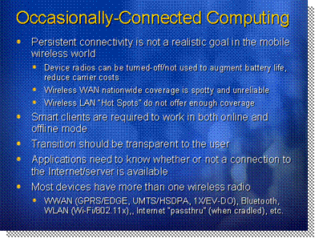
*****************************illegal for non-trainer use******************************
The world of mobile computing encompasses a plethora of devices with a wide variety of options, settings and capabilities for networking. At one extreme, you can have a device that can only network when physically docked to another computer inside the corporate network. At the other extreme, you can have devices that are connected whenever cellular coverage is detected.
Introduction
Wireless networks are becoming increasingly common. However, wireless coverage is neither 100% available nor 100% reliable. In addition, the security and quality of wireless networks varies wildly. You may have one user with a high speed, reliable, secure network and another user in the next building who has a poor signal on a wide open and insecure network. Therefore you can never design a mobile application that relies on the presence of a network connection.
The reality of wireless networks
Because you cannot rely on the presence, quality or security of a network connection, you must design your Web applications in a fashion that allows the application to work in both online and offline mode. Generally, this means you must store data locally until such a time as you can connect to the network and synchronize your local data with the home office.
Working in online and offline mode
The key to designing mixed online/offline mode applications is to build in detection features that will seamlessly switch the application between online and offline modes. The user should never need to know whether the device is online or offline unless lack of a connection prevents access to key functionality.
Detection and transparency
Most devices have more than one wireless radio:
Devices and wireless radios
- Wireless WAN (GPRS/EDGE, UMTS/HSDPA, 1X/EV-DO)
- Wireless LAN (Wi-Fi/802.11x)
- Bluetooth, Internet “passthrough” (when cradled), etc.

Network-Aware Computing
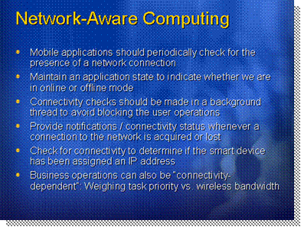
*****************************illegal for non-trainer use******************************
Mobile applications should regularly check for the presence of a valid network connection. Connectivity checks let your application determine which features are enabled or disabled, and whether to work in an online or offline mode.
Introduction
The easiest way to check for connectivity is to simply check whether the mobile device has a valid IP address assigned. The first step in creating a network connection is acquiring an IP, and the first step when a connection is lost is releasing the IP.
Checking for a Connection
Generally, you will want to check for connectivity using a background thread on a timer. That way the connectivity check won't interfere with normal device functions.
The SystemState class in the Microsoft.WindowsMobile.Status also exposes the following properties which can help detect connectivity:
- ConnectionsCount gets a value indicating the number of connections that are currently connected.
- ConnectionsNetworkCount gets a value indicating the number of network connections that are currently connected.
- Phone1xRttCoverage gets a value indicating whether the phone currently has 1xRTT coverage.
- PhoneGprsCoverage gets a value indicating whether the phone currently has GPRS coverage.
- PhoneNoService gets a value indicating whether the phone is not currently connected to a network.
- PhoneRadioOff gets a value indicating whether the phone's radio is turned off.
- PhoneRadioPresent gets a value indicating whether the mobile device has a phone.
- PhoneSearchingForService gets a value indicating whether the phone is currently searching for service on a network.
- PhoneSignalStrength gets the phone signal strength, expressed as a percentage of full strength.
Once you've set up your background polling thread, you can leverage some additional features of the Windows Mobile 5.0 operating system in order to notify users of connectivity status by using the connectivity icon and message popup.
Notifying the User
The .NET Compact Framework itself does not provide mobile developers with a simple and consistent mechanism for determining whether a device is docked or cradled. Because a docked device uses the IP address of the host computer, the previous method won't work. Most devices have their own special SDK's and API's for the device type and the docking mechanism. Therefore you would typically have to write your own device-specific code to determine whether the device is docked or not.
Check for Cradling
If you are targeting the Windows Mobile 5.0 platform you can however use the SystemState class in the Microsoft.WindowsMobile.Status, which exposes the following properties, to detect cradle connectivity:
- ActiveSyncStatus gets ActiveSync's current synchronization state.
- CradlePresent gets a value indicating whether the device is connected to a cradle.
Business operations can also make sure that they use certain connection types. Sending massive updates over a slow GPRS connection might not be desirable. Simply monitoring whether connectivity to the server is available or not is often not enough. You should then specify the relative "importance" value of each remote request when creating that request. A dispatcher service on the device should then use all this information to determine when, and over which connection type, it will dispatch each request. This allows you to manage task/request priorities with regards to the available wireless connections and their associated bandwidth.
Prioritizing connection types

Pattern-Oriented Software Architecture for Mobility
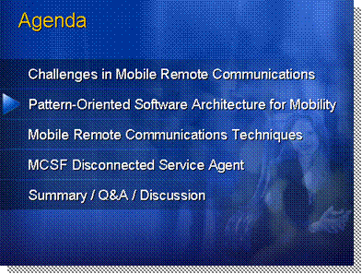
*****************************illegal for non-trainer use******************************
This section covers the use of design and architectural patterns from the perspective of designing and building mobile smart client applications. Patterns are an efficient and elegant way of documenting known problems and their solutions. Patterns have been identified, documented and detailed by some of the foremost experts in software architecture and design. They are not only a great source of knowledge in how to solve common problems in software design and development, but they also provide architects, developers and designers with a common vocabulary which can be used to express complex ideas and solutions using simple well-defined terms.
Agenda
This section explores how you can leverage common patterns when designing and building mobile applications. The discussion is a review of the patterns you can implement for the communication channels used between device and server.

Applying Known Patterns to Mobile Computing
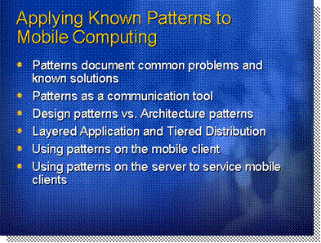
*****************************illegal for non-trainer use******************************
Patterns have become a popular way for software architects, designers and developers to document commonly found problems and challenges along with well known solutions for them. While patterns have often been associated with distributed and enterprise computing, it is important to note that mobile developers building applications for the enterprise can still benefit from them.
Introduction
Patterns are primarily used to document common problems and their known solutions. This promotes consistency and quality in software design practices by applying “design reuse” principles where the wealth of design knowledge from the industry can be shared by both novice and expert designers. It also prevents inexperienced designers from leading their designs astray by adopting less than ideal or highly complex solutions for commonly solved problems.
The role of patterns
Patterns are also a communication tool that provides a common vocabulary of shared terms between architects, designers and developers. Instead of documenting designs and architectures with lengthy descriptions, patterns can greatly simplify design documents by properly labeling design elements with the proper pattern name and simply extending them with the specifics of the implementation.
There are two main categories of patterns: design patterns and architecture patterns. Design patterns apply at the code and object level and will typically only affect the internal object structures and coding techniques used within components and assemblies. Architecture patterns apply at the component level, where they are assembled into systems or wrapped as services.
Design vs architecture patterns
Using separate assemblies and components to create layers such as business layers, data layers, and other functionality or technology-oriented layers is a common technique in distributed systems. There is however a common misconception that layering necessarily means a widespread physical distribution. Layering is a logical distribution; the physical distribution itself can be designed based on any kind of scenario or context.
Distribution and layering
This principle is especially important in mobility scenarios where the mobile client can contain several layers on the same physical tier. This maintains the benefits of layering without requiring a constantly connected architecture.
By properly relying on layering, mobile applications can be designed to separate the user interface, business logic, data access logic and remoting services into individual assemblies. These logical layers all live on the client tier but still provide the benefits of easy reuse of the layers for different user interfaces (e.g. Pocket PC, Smartphone, etc.), loose coupling for easier maintenance of the code and more granular testing, and a modular architecture that is better suited for future needs.
Using patterns in mobility
The patterns discussed here are all well-known patterns that have been documented by renowned architects and authors. In order to avoid distorting pattern explanations, the topics in this lesson use the original names and descriptions of several well known patterns as first documented in patterns books by their respective authors.
Learning more about patterns
The main sources of architecture and pattern documentation and also best practices on how to use them that you should be familiar with are:
- Enterprise Solution Patterns Using Microsoft .NET by Microsoft patterns & practices (published by Microsoft Corporation, 2003 (available online and in PDF format at http://msdn.microsoft.com/library/default.asp?
url=/library/en-us/dnpatterns/html/ESP.asp)
- Patterns of Enterprise Application Architecture by Martin Fowler (and David Rice, Matthew Foemmel, Edward Hieatt, Robert Mee, and Randy Stafford, published by Addison Wesley, 2002, ISBN 0-321-12742-0)
- Design Patterns by the Gang of Four (Erich Gamma, Richard Helm, Ralph Johnson, and John Vlissides, published by Addison Wesley, 1995, ISBN 0201633612)
- Pattern-Oriented Software Architecture: A System of Patterns by Frank Buschmann, Regine Meunier, Hans Rohnert, Peter Sommerlad, Michael Stal (published by John Wiley & Sons, 1996, ISBN 0-471-95869-7)
- Pattern-Oriented Software Architecture: Patterns for Concurrent and Networked Objects by Douglas Schmidt, Michael Stal, Hans Rohnert, Frank Buschmann (published by John Wiley & Sons, 2000, ISBN 0-471-60695-2)
- Domain-Driven Design: Tackling Complexity in the Heart of Software by Eric Evans (published by Addison Wesley, 2003, ISBN 0-321-12521-5)
- Applying Domain-Driven Design and Patterns, With Examples in C# and .NET by Jimmy Nilsson (published by Addison Wesley, 2006, ISBN 0-321-26820-2)
- Application Architecture for .NET: Designing Applications and Services by Microsoft patterns & practices (Solution Architect & Program Manager: Edward A. Jezierski, published by Microsoft Corporation, 2002, available online and in PDF format at http://msdn.microsoft.com/library/default.asp?
url=/library/en-us/dnbda/html/distapp.asp)
It is recommended that you familiarize yourself with these works and especially with the patterns mentioned in this session since these presentation notes are not meant to be a replacement for the base theory, but rather a complement on how they are relevant to mobility scenarios. Many pattern descriptions and graphs are quoted directly from these works.

Synchronous vs. Asynchronous
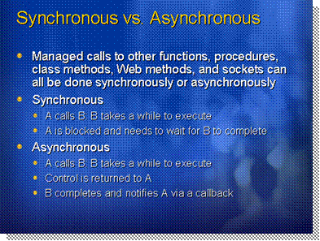
*****************************illegal for non-trainer use******************************
Mobile device users expect their applications to work regardless of the connectivity state. In order to meet this expectation, you will often have to design your application to take advantage of asynchronous communication.
Introduction
Most normal programming involves chaining together a sequence of operations in a linear fashion. When you submit a work order, you might expect the sequence of events to be:
Synchronous calls
- Validate the order locally.
- Transmit the order to the home office.
- Receive verification from the home office.
The problem is that, if your device is disconnected, step 2 never completes. Your application will be waiting to transmit the order until connection is restored. That means your user can't enter a second order until he gets back on the network.
In an asynchronous call, you separate the direct connection between the request and the response. In our previous example, you would actually have three different processes running:
Asynchronous calls
- Process 1 - User creates work orders that are validated locally. When the order is validated, it's passed to process 2.
- Process 2 - If a network connection is available, the order is sent to the home office. If a network connection isn't available, the order is queued for when connectivity is restored.
- Process 3 - If a network connection is available, this process listens for confirmations from the home office. Once a confirmation is received, process 3 notifies process 1 to update the user on the order status.
By making the sequence asynchronous, you allow the user to enter multiple orders and continue working if a network connection isn't available.
In order to make asynchronous calls a reality, you will have to work with threading. Each active thread in a program acts like its own mini-program by running a sequence of tasks independent of the other threads.
The .NET Compact Framework offers a range of thread options identical to those found in the full .NET Framework. For example, to create a connection checker thread, you would need to:
Creating a Background Thread
- Create a class that has a method for checking the IP address.
- In your main startup function for your application, you would need to create a new Thread object that references the connection checker class and method.
- Once you have a Thread object, you need to execute the Start() method to launch the method identified in your Thread.
Note that for your thread checker to work properly, the checker method would have to contain an infinite loop to repeatedly check for an IP, set the connection status, and then sleep for an arbitrary time (a few seconds). Your loop should actually check a Boolean property to see whether the thread should continue to run or not. You can find a good example at http://msdn.microsoft.com/webservices/default.aspx?pull=/library/en-us/dnnetcomp/html/BackgroundProcess.asp.
Another aspect of threading involves user interface controls. The UI system is already designed to work in a multi-threaded fashion thanks to events and delegates. However, it is limited in that once you push a button or click on a link, the UI is blocked until that process is finished.
Threading and Controls
You also have to remember that Windows Forms is not thread safe, which means that the only thread that should perform updates in the user interface is the main thread where those controls were created and are running. You should never try to directly access user controls from background threads.
The .NET Framework stack for Web services has built-in functionality for making asynchronous calls. Every method in a Web service proxy class has an accompanying pair of Begin and End methods. For example, if your application had to connect to a Web service to submit an order, the sequence of events would be:
Asynchronous Web Calls
- User presses the "Submit" button.
- Submit code calls the WorkOrder.BeginSubmit() Web service method, passing in all parameters and an AsyncCallback object. The callback object wraps up a method that will be called when the Web service call actually completes.
- Submit button code is finished, UI is unlocked and the user can continue their work.
- Built-in listener thread receives a response from the Web service and executes the callback method from step #2.
- Callback method retrieves result using the WorkOrder.EndSubmit() method.
- Result is displayed to the user.
Because the sequence is asynchronous, there will be a variable time delay between step 3 and step 6. The delay may be short if the device is connected to a high speed network, or it may be long if the network is lower quality.
You can also combine this type of asynchronous call with the connectivity checker thread. In other words, you probably want to have a queue involved in step 2 so that if the device isn't connected, the request goes into the queue rather than trying to call a Web service that is unavailable.

Mobile Remote Communications Techniques
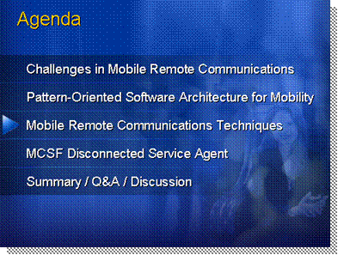
*****************************illegal for non-trainer use******************************
This section covers the various mobile remote communications techniques developers can adopt to move data between the client device and the server. Many alternatives are presented since not one technique is ideal for all scenarios in enterprise mobility. Developers and architects need to understand the context of their application and how one option might be better than another depending on a variety of factors.
Agenda

Remoting and Networking Techniques for Mobile Clients
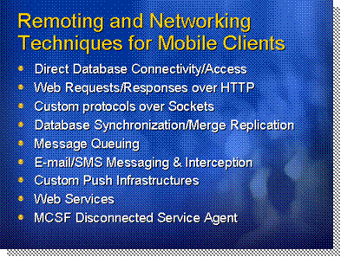
*****************************illegal for non-trainer use******************************
Communicating with the server-side and the rest of your corporate network infrastructure is a key aspect of any mobile smart client application that lives within a distributed enterprise architecture. Whether you encapsulate remoting techniques within a remoting and networking layer (RNL) or you embed them directly with your business and data objects, many alternatives are open to the mobile developer seeking an efficient communication scheme between device and server.
Introduction
This topic explores the most common of these remoting and networking techniques from a high level overview.
Web services provide a simple and flexible method for transmitting and returning data between clients and data sources. If your application must access data from multiple sources, interoperate with other applications, and work frequently in a disconnected state, consider using Web services to exchange various data structures with the server, including standard data types, objects, DataSets, XML documents and other complex data types.
Web services
Web services enable applications to serialize DataSets and other objects as XML for data transmission, while persisting the results locally. This solution works well for applications that use low volumes of data, use queries that are limited in scope and complexity, and make few offline changes. More complex querying of locally cached data is inefficient.
By focusing solely on a message-based system, the Web services model does not rely on any specific language, platform, or object model. Web services are based on open Internet standards, such as HTTP and XML, and thus benefit from a well established infrastructure.
In addition to working locally with disconnected data, Web Service client applications can synchronize data periodically with a remote server. Although the server controls synchronization, the complex state and synchronization logic can present some issues. In the case where multiple users are working with data locally by using Web services, conflicts can occur. The last user to update the data to the server would have their changes written to the database, with potentially unexpected consequences. The extra work required to mitigate such problems is considerable.
It is a known fact that XML adds a considerable overhead to all network communications. This overhead requires more processing power for the serialization and deserialization of XML data and more memory for the parsing of XML data. XML also requires more network bandwidth since an XML document can be anywhere from 2-10 to 1 in size when compared to its binary format equivalent. Add the overhead of a high level Web protocol like HTTP compared to TCP/IP and the cost of using Web services becomes clear.
Web services do have their place in mobility scenarios. Their flexibility in crossing Internet boundaries for remote communications makes them ideal for mobile applications to converse with corporate servers from the field. You simply have to remember that this flexibility comes at a cost and you should test and benchmark your mobile applications accordingly.
Web services are covered in more detail in module 3 of this course.
The WebRequest and WebResponse classes in the System.Net namespace provide the abstract base classes for the .NET Compact Framework request/response model for accessing data from the Internet. Instances of WebRequest request data from the Internet without regard to the specific communications protocol, while protocol-specific descendant classes fulfill the details of the request. In the case of HTTP, the HttpWebRequest class performs this function.
HTTP Request/Response
While data access technologies such as ADO.NET and XML Web services work well in many enterprise application scenarios, you may sometimes need to consider a lower level of control over network access in your applications. In this case, you may need to program at the sockets level. Although programming with sockets is beyond the scope of this course, this topic highlights some .NET Framework classes in the System.Net.Sockets namespace that can provide you with more control over the lower level networking functions.
Sockets
Windows Sockets provide an abstraction of the underlying network, thus ensuring that you don’t need to be knowledgeable about that network. The use of Windows Sockets also guarantees that your applications can run on any network that supports sockets. In addition, if you implement any kind of remoting in your applications, you do so through sockets. The System.Net.Sockets namespace provides a managed implementation of the Windows Sockets (Winsock32 API) interface.
In particular, mobile device applications can benefit from Infrared Data Association (IrDA) standards that support wireless point-to-point networking. The Microsoft .NET Compact Framework provides the IrDAClient, IrDADeviceInfo, and IrDAListener classes, which you can use to implement wireless networking in your applications.
The NetworkStream class provides the underlying stream of data for network access, with methods for sending and receiving data over stream sockets in blocking mode. You can also use the NetworkStream class for asynchronous data transfer. A NetworkStream requires a connected socket.
Using Web services with DataSets works well when you want to retrieve a small amount of data to a device, perform some updates locally, and transmit the data back to the data source. However, sometimes you must access a remote data source directly, and then manipulate data while connected to the data source. In this case, one of the .NET data providers is a good alternative.
Direct database access
You use a data provider to retrieve data from a data source and to resolve changes to that data back to the data source. The .NET Compact Framework includes the .NET Framework Data Provider for SQL Server (for Microsoft SQL Server version 7.0 or later), which is a managed provider that does not have to rely on COM interop to communicate with native OLE DB.
The .NET Compact Framework Data Provider for SQL Server supplies a lightweight layer between the data source and your application that provides direct access to a SQL Server database. Because an application that uses the SQL Server .NET Provider to access a computer running SQL Server does not have go though additional OLE DB or ODBC layers, it performs well.
When an application accesses a SQL Server database directly, it has access to a large data source. This contrasts with the disconnected model, where a DataSet provides an application with a subset of data to work with locally before synchronizing with the original data source. With direct remote data access, an application can query the entire data source and obtain useful results.
Direct database access relies on a constant connection, which may not work for every mobile device application scenario. Also, when working directly with a remote database, there is no model to deal with synchronizing more dynamic data. This situation contrasts with a disconnected model in which an application makes updates locally, and then periodically synchronizes with the data source.
Microsoft SQL Server 2005 Mobile Edition (also known as SQL Server CE 3.0) supports two synchronization technologies: remote data access (RDA), and merge replication. Mobile devices that are capable of connecting to the Internet can synchronize data by using either of these two technologies. Both replication models are Internet-based. SQL Server CE synchronizes with SQL Server on the server-side by establishing an HTTP connection to the SQL Server Publisher by using IIS. Connecting through IIS allows replication to use IIS authentication and authorization services.
Synchronization
RDA and merge replication both require a SQL Server database. However, the enterprise database can be any database, such as Oracle or DB2. In a complex scenario, you may use SQL Server as a middleware solution between the mobile devices and the enterprise databases. After one or more mobile devices synchronize data with SQL Server, the data is available to other databases and can be accessed using XML or other technologies, such as the Data Transformation Services (DTS).
Database synchronization is covered in greater detail in module 3 of this course.
Message Queuing makes it easy for application developers to communicate with application programs quickly, reliably, and asynchronously by sending and receiving messages from queues. Message Queuing solves the problem of fragmented communication patterns and maintains the integrity of data even over unreliable networks like the wireless Internet. This makes it an ideal candidate technology for mobility scenarios.
Message queuing
With Message Queuing, applications send messages to queues and read messages from queues. When you use Message Queuing, you can create or delete message queues, send or receive messages, and manage message queues. Windows CE supports MSMQ CE as a lightweight version of MSMQ (Microsoft Message Queuing) which is compatible with Message Queuing Services on the server-side. Messages can also be sent over the Internet if the client application runs on Windows Mobile 2003 or 5.0 (or on any device based on Windows CE 4.0 or later).
In the .NET Compact Framework, messaging is handled by the System.Messaging namespace. The System.Messaging namespace provides classes that enable you to connect to, monitor, and work with private message queues on the device and to send, receive, or view messages. Using this namespace enables components that are written in a managed language to send and receives messages from Message Queuing.
Asynchronous messaging with the .NET Compact Framework is covered in more detail in module 3 of this course.
E-mail-based messaging is a technology that has always been destined to be used to interact with human beings. The same goes for SMS messaging, which is a simple messaging technology that reuses the control channels on a cellular network to send and receive short (typically 160 characters) messages from a cellular phone. While these technologies were never intended to be used for inter-process application-to-application communications, there have been several occurrences where mobile developers have reused these protocols to exchange machine-oriented messages between client and server applications.
E-mail/SMS
From a .NET Compact Framework application running on Windows Mobile 5.0, you can use the Microsoft.WindowsMobile.PocketOutlook namespace provided with the Windows Mobile 5.0 SDK where several classes are available to send and receive e-mails and SMS messages. Note that using such a technique means you have to manage your own high-level messaging protocol from both ends and you also run the risk of interfering with the end user’s standard e-mail and SMS communications.
Finally, you can leverage new application blocks provided by the Mobile Client Software Factory for remote networking and connectivity management. The application blocks provided are:
Application blocks in the Mobile Client Software Factory
- The Connection Monitor Block, which monitors and exposes connections between the device and the gateway that connects it to the back-end services and data sources it uses. The Connection Monitor Application Block provides the following features:
  - Connection enumeration. This feature enumerates all the connection types registered for the device, irrespective of whether they are currently connected.
  - Network enumeration. This feature enumerates all the networks available to for the device, irrespective of whether they are currently connected.
  - Network connectivity. This feature provides an indication of current connectivity by raising events that the application can subscribe to so that it receives notification when the network connection status changes.
  - Pricing. This feature associates a cost with each type of connection, using whole number values. Applications can choose the appropriate connection type to send messages to the server, or they can prioritize message delivery based on the connection type.
- The Disconnected Service Agent Block, which provides features for storing offline Web Service requests, and executing them when connectivity is available. With a disconnected service agent, the device can maintain a queue of Web service requests when offline (disconnected) and then replay them when a connection to the server application becomes available. This means that applications can work in a disconnected environment; this is a crucial requirement in many scenarios.
There are two distinct features in the Disconnected Service Agent Application Block. They are:
  - A subsystem that allows developers to invoke disconnected Web services using patterns similar to those they are familiar with from using Visual Studio Web Services proxies. However, the disconnected service agent queues requests and keeps track of the asynchronous callbacks that the application expects to receive when the Web service responds.
  - A dispatcher that determines exactly when to dispatch each call to a Web service, depending on connectivity conditions and pricing policies. When the correct conditions occur, the dispatcher makes the request, using the appropriate credentials and addresses for the endpoint.

Direct Database Access
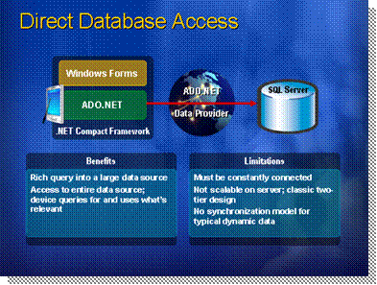
*****************************illegal for non-trainer use******************************
Using Web services with DataSets works well when you want to retrieve a small amount of data to a device, perform some updates locally, and transmit the data back to the data source. However, sometimes you must access a remote data source directly, and then manipulate data while connected to the data source. In this case, one of the .NET data providers is a good alternative.
Introduction
You use a data provider to retrieve data from a data source and to resolve changes to that data back to the data source. The .NET Framework includes the .NET Framework Data Provider for SQL Server (for Microsoft SQL Server version 7.0 or later), and the .NET Framework data provider for OLE DB. Both are managed providers, but the .NET Framework Data Provider for OLE DB relies on COM interop to communicate with native OLE DB.
.NET Framework data providers

A .NET Framework Data Provider for Open Database Connectivity (ODBC) is also available as a separate download at http://msdn.microsoft.com/downloads. This lesson focuses on the .NET Framework Data Provider for SQL Server.
Note

The .NET Framework Data Provider for SQL Server supplies a lightweight layer between the data source and your application that provides direct access to a SQL Server database. Because an application that uses the SQL Server .NET Provider to access a computer running SQL Server does not have go though additional OLE DB or ODBC layers, it performs well.
Benefits and limitations of direct database access
When an application accesses a SQL Server database directly, it has access to a large data source. This contrasts with the disconnected model, where a DataSet provides an application with a subset of data to work with locally before synchronizing with the original data source. With direct remote data access, an application can query the entire data source and obtain useful results.
Direct database access relies on a constant connection, which may not work for every mobile device application scenario. Also, when working directly with a remote database, there is no model to deal with synchronizing more dynamic data. This situation contrasts with a disconnected model in which an application makes updates locally, and then periodically synchronizes with the data source.

Data Replication Models
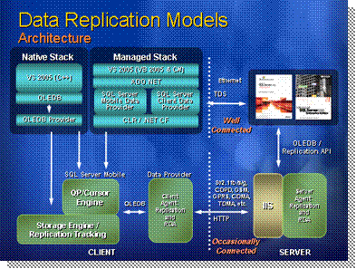
*****************************illegal for non-trainer use******************************
SQL Server 2005 Mobile Edition is designed to run efficiently on typical mobile devices, such as Microsoft Mobile Pocket PCs. It is designed to be a disconnected database in a mobile device. It extends SQL Server functionality to mobile devices and includes both an optimizing query processor and reliable, scalable bidirectional merge replication capabilities.
Introduction
SQL Server 2005 Mobile Edition provides integrated support for the .NET Compact Framework. SQL Server 2005 Mobile Edition runs on any device based Microsoft Windows CE 5.0, Microsoft Windows XP Tablet PC Edition, Windows Mobile 2003 Software for Pocket PC, or Windows Mobile 5.0.
SQL Server 2005 Mobile Edition is an OLE DB provider, rather than a service like SQL Server 2005. This is because Windows CE does not support background services like Windows NT-based systems. SQL Server 2005 Mobile Edition is a database with a DLL wrapper. This allows SQL Server 2005 Mobile Edition to support Microsoft ActiveX® Data Objects for Windows CE (ADOCE) and OLE DB for Windows CE APIs. The OLE DB provider runs in processes. Multiple applications running at the same time can share a common set of DLLs, thereby saving memory.
OLE DB DLL
Some SQL Server 2005 Mobile OLE DB interfaces differ from the generic interfaces described in the OLE DB specification. For more details about these differences, see the SQL Server 2005 Mobile Edition documentation.
Although a mobile application can be a stand-alone application, it will often be a part of an enterprise-wide distributed application. The client agent is a DLL that allows SQL Server 2005 Mobile Edition to communicate with SQL 2005 by using merge replication or Remote Data Access (RDA). Users can work with a subset of data from a larger enterprise database. For example, the mobile user downloads a subset of data from the enterprise SQL database into the mobile device, and then disconnects from the remote data source to work remotely. After reconnecting, changes are synchronized with the enterprise data. The mobile device and the enterprise server do not have to be constantly connected.
The client agent
A basic understanding of the available data synchronization technologies will enable you to choose the appropriate data synchronization strategies for your mobile enterprise applications. SQL Mobile 2005 supports two synchronization technologies: remote data access (RDA), and merge replication. Mobile devices that are capable of connecting to the Internet can synchronize data by using either of these two technologies.
SQL Mobile 2005 synchronization options
RDA is easy to implement and use. Using RDA, you can download entire tables or subsets of tables from SQL Server version 6.5 with Service Pack 5 or later.
Merge replication requires SQL Server 2000 or 2005 as the central database. Merge replication provides a more robust synchronization solution, because it is bidirectional. Merge replication detects changes to data on both the remote server and the SQL Server CE device, and then synchronizes the changes in both directions.
RDA and merge replication both require a SQL Server database. However, the enterprise database can be any database, such as Oracle or DB2. In a complex scenario, you may use SQL Server as a middleware solution between the mobile devices and the enterprise databases. After one or more mobile devices synchronize data with SQL Server, the data is available to other databases and can be accessed using XML or other technologies.
Other database support
Replication uses the publish/subscribe model in which one database
(SQL Server 2005) publishes data to which other databases on mobile devices can subscribe. RDA provides a simpler solution whereby mobile devices pull data, push data, or both. In each case, the mobile application initiates the data transfer.
Synchronization
Several enhancements are available to improve the process of replicating and synchronizing data with SQL Server 2005 Mobile Edition compared to SQL Server CE 2.0. The enhancements include the following:
New features in SQL Server 2005 Mobile Edition
- Support for multiple subscriptions – In earlier versions of SQL Server CE, only one subscription could be created for each database. In an environment where the published data derives from multiple publications, a developer had to create a separate subscription database for each publication, and then specify which database the application needed to open.
- Multi-user support and synchronization – To support multiple applications accessing the same database at the same time, SQL Server Mobile provides multi-user support. Multi-user support enables multiple users of a database to synchronize data without having to disconnect the database before they use merge replication or remote data access (RDA).
- Synchronization progress status – Developers can use the managed APIs to provide synchronization status feedback, which can be used to inform users of synchronization progress.
- Column-level tracking – In earlier versions of SQL Server CE, a whole row was synchronized with Microsoft SQL Server, even if only one column in the row had been modified. This frequently resulted in longer synchronization times if the unmodified columns in the row contained lots of data. In SQL Server Mobile, only the modified columns are synchronized.

Merge Replication
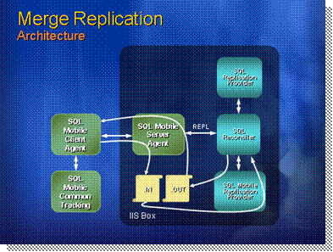
*****************************illegal for non-trainer use******************************
SQL Server 2005 Mobile Edition replication is based on SQL Server 2005 and 2000 merge replication. Replication is well suited for mobile devices because data can be synchronized between one or more mobile devices and the server.
Introduction
SQL Server 2005 Mobile Edition synchronizes with SQL Server by establishing an HTTP connection to the server by using Microsoft Internet Information Services (IIS). This communication model differs from that used when you implement merge replication between two SQL Server 2005 databases. You use the IIS connection for SQL Server 2005 Mobile Edition replication so that replication can use IIS authentication and authorization services.
Connects over HTTP
Replication implements a publish/subscribe model that allows mobile devices running SQL Server 2005 Mobile Edition to become subscribers to information that is published by the server. In this model, the source database is maintained at the publisher, which specifies the data that will be published to subscribers. A copy of the published data is maintained on the subscriber. Between the two is a distributor, which maintains a distribution database and tracks the replication status of data that is synchronized between the publisher and the subscriber.
Publish/subscribe model
A mobile device that implements SQL Server 2005 Mobile Edition cannot be a publisher or a distributor. It can only be a subscriber. Thus, the mobile application is responsible for initiating and controlling replication. The application creates the subscription, downloads the initial snapshot of the publication, and triggers data synchronization as needed. SQL Server 2005 Mobile Edition does not provide administrative functions for these tasks. You must build them into your application.
In a large mobile application deployment, you may have many mobile devices that subscribe to the same publication. Each subscriber has the ability to make changes independently of other subscribers. Because SQL Server 2005 Mobile Edition is configured to be an anonymous subscriber, the publisher controls all changes and sends updates to all other subscribers. To avoid conflicts that result from different users making changes to the same data, you should design your application so that each user downloads different subsets of data. If it is not possible to do so, you may need to design custom conflict resolvers in the publisher database.

Supports multiple users
Some items cannot be propagated to the SQL Server 2005 Mobile Edition Subscriber. These items include stored procedures, views, triggers, CHECK constraints, user-defined functions, and extended properties. You must implement equivalent logic in the mobile application to ensure that the local database is consistent with the SQL Server database.
Items that cannot be published to SQL Server 2005 Mobile Edition

Remote Data Access
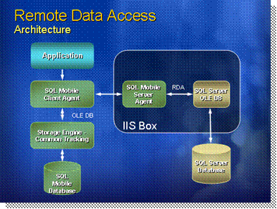
*****************************illegal for non-trainer use******************************
Remote data access (RDA) provides a simple way for a Microsoft Windows CE-based application to exchange data with a remote Microsoft SQL Server database. RDA was developed specifically for applications that do not require the robust features of merge replication.
Introduction
RDA is particularly suited to downloading static data from an enterprise server to a mobile application. For example, if your application validates data entry by using a lookup table, an initial data download can populate the lookup table. Because users do not modify data in the lookup table, you do not have to upload changes. You only need to resynchronize the table if it is modified in the SQL Server central database system.
Static data download
You can also use RDA to capture new data in a mobile application and upload it to an enterprise server. For example, you may use a mobile device that is equipped with a bar code reader to record items that are shipped or received at a loading dock. The mobile application stores the data in a SQL Server 2005 Mobile Edition database and periodically pushes the data to the enterprise SQL Server database. You do not have to synchronize data in the mobile device, but you may have to provide business logic in the enterprise server to process the incoming data.
Data capture and upload
An application running on a mobile device can pull SQL Server data to a SQL Server 2005 Mobile Edition database, make changes to the data, and then push the changes back to the SQL Server database. For example, you can download a delivery schedule, record the actual time of each delivery, and then push the schedule back to the main server. An optional tracking parameter keeps track of rows that change in the SQL Server 2005 Mobile Edition database. This reduces the upload requirements because the application only uploads to the SQL Server database those rows that change.
Data download, update, and upload
SQL Server does not track data changes. Therefore, each time the mobile application requires a copy of data from a table in SQL Server, your application must delete the local table and pull a new version of the table from SQL Server.
A mobile application may use more than one of these techniques. For example, you may choose to pull with the tracking parameter turned off to download a lookup table. At the same time, you may pull with the tracking option turned on to download an order tracking table that will be pushed after you update the data. Finally, by using a bar code reader, you may capture new information that is submitted to a SQL Server table.
Combining techniques
RDA communicates with SQL Server by using Hypertext Transfer Protocol (HTTP) through Microsoft Internet Information Services (IIS), allowing RDA to take advantage of IIS authentication and authorization services.
Internet protocols
To reduce bandwidth requirements, RDA uses compression to reduce the amount of transmitted data. If the wireless connection is lost, RDA waits until the signal is detected, and then continues to transmit data from the last successfully transmitted message buffer.
RDA provides three ways to exchange data between a SQL Server 2005 Mobile Edition device and SQL Server. RDA enables you to pull data from SQL Server, push changes back to SQL Server, and submit SQL statements that will be executed on the server. The Windows Powered mobile device application always initiates and controls RDA. Your application should call the appropriate method in the System.Data.SqlServerCe.SqlCeRemoteDataAccess class.
Using RDA
Method | Description
Pull | Pulls data from a SQL Server table and stores it in a SQL Server 2005 Mobile Edition table.
Push | Sends changes from a tracked table in SQL Server 2005 Mobile Edition back to SQL Server, where the changes are merged into the original table.
SubmitSql | Submits SQL statements to be executed on a remote SQL Server database.
Dispose | Releases all native resources.

Reliable Messaging in a Mobile Wireless World
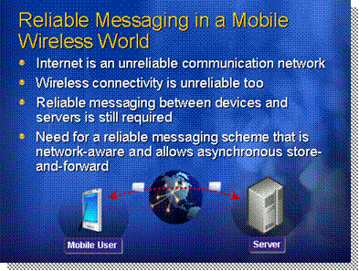
*****************************illegal for non-trainer use******************************
The Internet is, by design, an unreliable communication network. That means that you can never really be sure if your messages get through from your device to the home office (or vice versa). At any time, any node between your device and your target device may go offline, loose power, or fail. Wireless networks compound the problem as signal strength may increase or decrease simply by moving about in a room.
Introduction
If you need to guarantee that your messages are received, you need to use a reliable messaging scheme that is asynchronous. Asynchronous communication is a requirement for any reliable message protocol because you cannot guarantee that your sending system or the target system will remain online and connected while a confirmation is being generated and sent.
Mobile application developers should consider three main challenges in terms of network communication:
The reality of unreliable networks
    - Receipt of Data - Can you confirm receipt of data? Did the home office get your urgent work order or not? How do you know?
    - Data Integrity - Can you confirm integrity of data? Are you sure the home office received the right price and quantity of parts? Did someone tamper with the message along the way?
    - Connectivity - What happens if you lose connection mid-message?

Message Queuing and MSMQ
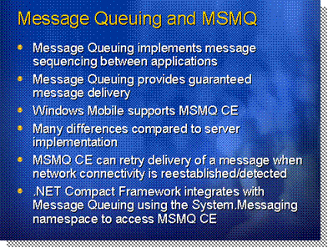
*****************************illegal for non-trainer use******************************
Message Queuing makes it easy for application developers to communicate with application programs quickly, reliably, and asynchronously by sending and receiving messages from queues.
Introduction
Message Queuing is a technology that implements message queuing in an application. Applications send messages to queues and read messages from queues. When you use Message Queuing, you can create or delete message queues, send or receive messages, and manage message queues.
Message Queuing implements message sequencing between applications
Transactions are an important part of enterprise systems, which frequently require the asynchronous capabilities of Message Queuing. Message Queuing provides guaranteed message delivery, efficient routing, security, and priority-based messaging.
Message Queuing provides guaranteed message delivery
For example, the order processing system is an example of asynchronous operation: a client’s request might be posted as a message to the Message Queuing. After writing the message, the message sending code continues without waiting and a separate process, message receiving code, reads the message from the queue and then acts on it to execute the asynchronous operation.
In the .NET Compact Framework 2.0, messaging is handled by the System.Messaging namespace. The System.Messaging namespace provides classes that enable you to connect to, monitor, and administer message queues on the network and to send, receive, or view messages. Using this namespace enables components that are written in a managed language, such as Microsoft C# or Visual Basic® .NET, to send and receives messages from Message Queuing.
.NET Framework integrates with Message Queuing using the System.Messaging namespace
Simply add a reference to the System.Messaging namespace in your .NET Compact Framework 2.0 project, or drag a MessageQueue component on your form.
However, MSMQ for Windows CE is a subset of desktop implementation. It cannot read messages from queues on a remote machine and can only function as an independent client. Thanks to a simpler architecture, it does not require access to a domain controller or message queuing server to operate. With no Active Directory support on Windows CE, MSMQ CE cannot query Active Directory to locate queues, so you must know queue location in advance at design-time.
Limitations and differences
At the transactional level, MSMQ CE cannot participate in coordinated transactions via MS DTC. However, it does support single message transactions; i.e., guaranteed, once-only, in-order delivery on the sending (not receiving) of messages.
Public queues are not supported with MSMQ CE. You can only create local, private queues.
MSMQ CE does exceed desktop MSMQ capabilities in certain areas. It supports NIC tracking, which allows MSMQ CE to retry delivery of undelivered messages as soon as (or after a specified wait time) MSMQ CE senses a network reconnect, such as when a wireless connection is regained.
The following requirements must be met to use MSMQ on Windows Mobile devices with .NET Compact Framework 2.0:
Requirements
    - Windows CE 4.2 or 5.0 with MSMQ support built-in
    - Windows Mobile 2003 for Pocket PC or Smartphone. Native MSMQ components from Pocket PC 2003 SDK or Smartphone 2003 SDK are also required.
    - Windows Mobile 5.0 for Pocket PC/Smartphone. An MSMQ CAB file is included in the Windows Mobile Redistributable Components package.

Pushing Live Alerts and Field Notifications to Mobile Devices
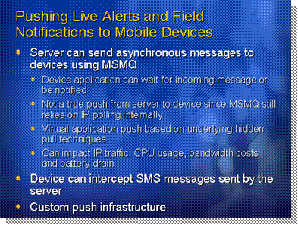
*****************************illegal for non-trainer use******************************
One common approach to sending alerts out to mobile devices is to use MSMQ. The home office can set up an alert queue, and any alert messages will automatically be sent to subscribed devices whenever those devices regain network connectivity.
Introduction
Using MSMQ CE and the System.Messaging namespace, server applications can easily send alerts, job updates or any kind of data to mobile devices. Just like e-mail technology, devices do not have to call the server at regular intervals and poll for updates; they can simply wait for an update to come in by monitoring a local queue.
Pushing data
The problem with MSMQ is that it is not a true push implementation. While the protocol looks like it is listening for messages pushed from the server, in reality the underlying protocol uses IP polling to ping the server for updates and fetch messages addressed to the device’s queue.
MSMQ CE considerations
This means that MSMQ technology can generate a lot of IP traffic, which in turn can augment the costs of wireless connectivity if you have to pay for every MB transferred over the connection. It can also generate more activity on your device CPU, which in turn can result in faster battery drain.

Using Web Services to Access Data
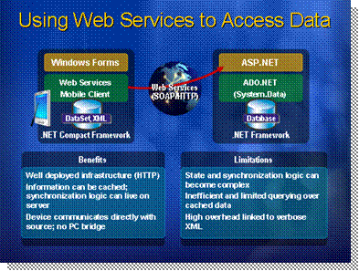
*****************************illegal for non-trainer use******************************
Web services provide a simple and flexible method for transmitting and returning data between clients and data sources. If your application must access data from multiple sources, interoperate with other applications, and work frequently in a disconnected state, consider using DataSets with Web services.
Introduction
Web services enable applications to serialize DataSets as XML for data transmission, while persisting the results locally. This solution works well for applications that use low volumes of data, use queries that are limited in scope and complexity, and make few offline changes. More complex querying of locally cached data is inefficient.
Working offline
By focusing solely on a message-based system, the Web services model does not rely on any specific language, platform, or object model. Web services are based on open Internet standards, such as HTTP and XML, and thus benefit from a well established infrastructure.
Open standards
In addition to working locally with disconnected data, Web service client applications can synchronize data periodically with a remote server. Although the server controls synchronization, the complex state and synchronization logic can present some issues. In the case where multiple users are working with data locally by using Web services, conflicts can occur. The last user to update the data to the server would have their changes written to the database, with potentially unexpected consequences. The extra work required to mitigate such problems is considerable.
Data synchronization
For more information about data synchronization, see Module 4, “Working with SQL Server™ 2005 and the Mobile Edition,” in Course 7026A, Developing Mobile Applications Using the Microsoft .NET Compact Framework 2.0.
Another advantage of using Web services is that you have direct communication between the mobile device and the data source. Like any consumer of the Web service, the mobile device can access the Web service without requiring Microsoft ActiveSync® or any special Microsoft Internet Information Services (IIS) application.
XML and Web services have gained momentum in desktop and server scenarios since that late 1990s, thanks to faster processors, more available memory for applications and higher network bandwidths on corporate intranets and to the Internet.
XML overhead
limitations
As was discussed earlier, mobile devices live in a more constrained world, where memory and processor speeds are more limited. The most severe limitation lies in network throughput speeds. Today’s average WWLAN network transfer rates are now capping at 144 kilobits per second (Kbps) in theory and around 50-80 Kbps in practical scenarios. Wireless broadband (EV-DO, UMTS/WCDMA, etc.) is slowly emerging but is far from widely available in all regions and on all devices yet. It is therefore critical for mobile application developers to closely monitor and control the amount of data sent over wireless connections.
It is a known fact that XML adds a considerable overhead to all network communications. This overhead requires more processing power for the serialization and deserialization of XML data and more memory for the parsing of XML data. XML also requires more network bandwidth since an XML document can be anywhere from 2-10 to 1 in size when compared to its binary format equivalent. Add the overhead of a high level Web protocol like HTTP compared to TCP/IP and the cost of using Web services becomes clear.
Web services do have their place in mobility scenarios. Their flexibility in crossing Internet boundaries for remote communications makes them ideal for mobile applications to converse with corporate servers from the field. You simply have to remember that this flexibility comes at a cost and you should test and benchmark your mobile applications accordingly.

Hybrid Pattern
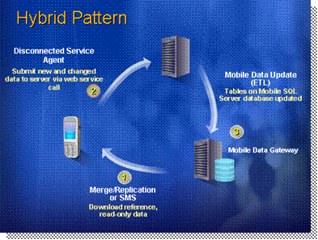
*****************************illegal for non-trainer use******************************
Sometimes there is no one solution that can fit all of our needs. The way that data initially makes its way to the device does not necessarily have to be the same technique for sending updates back to the server. If the use cases for both are very different, or if the environment context contains different variables for download than for upload, such as the available connection at the moment data is sent or the volume difference between upstream and downstream data, a hybrid approach might be needed.
Introduction
A hybrid pattern is where you combine two or more remoting technologies into a greater data flow subsystem. This has the advantage of providing a “best of both worlds” approach when a compromise is too restrictive.
Combining different approaches
The diagram shows such an example, with the following components:
- Merge/Replication or SMS: Replication technology can be a very efficient way of seeding the initial dataset users need to work with. In cases where mobile workers have to carry a lot of reference or read-only data, a bulk transfer makes a lot of sense as it does not require reconciling 2 datasets on the client. Before it is sent to the device, a snapshot is typically created by copying a subset of the data to be transferred to a mobile data gateway that acts as a staging area for mobile devices. Using Microsoft Systems management Server (SMS) to deploy files as part of a package targeted at devices is another way of performing such a batch update or seed.
- Web service/Disconnected service agent: Once the data has made its way to the device and changes are made to it, these smaller, more granular changes can be sent via Web services since a full replication infrastructure might not be needed. This is preferable when only one user has a chance of updating the same piece of data or record. If there is a high risk of conflict due to massive relational updates to the same records, merge replication is still a better option. The disconnected service agent is an alternative to the standard Web service calls as it allows for the remote call to be done asynchronously, by queuing it on the client side until a proper connection is established with the server.
- Mobile data update: Once updates and new records have been received from mobile users, or from desktop users internally, these have to be rolled out as part of an update that is sent to mobile devices. A mobile data update is then prepared and sent to the mobile data gateway using data transformation services or bulk updates or replication. In such a scenario, SQL Mobile could be used on the client device, SQL Server on the mobile data gateway, thus enabling replication support, while a third-party database like Oracle or UDB can be used to store the data received from Web service calls since those do not rely on replication technology.
The Disconnected service agent application block is covered in the next section.

Selecting a Data Replication Model
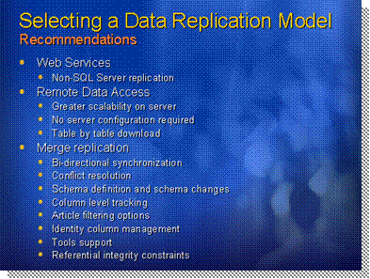
*****************************illegal for non-trainer use******************************
Given so many options, it sometimes becomes difficult to decide on a data replication model. Data has to move freely between the mobile device and the server, and many factors can affect which strategy is adopted, such as the nature of the data itself, the granularity and frequency of the updates, the volume of data involved, the type of device and connection used, the number of people consuming this data, and more.
Introduction
Web services use a message-based approach towards data replication. Because they are not tied to any specific database technology, they can easily be used as a proxy to any database, especially non-SQL Server replication, since SQL Mobile can only communicate with Microsoft SQL Server.
Web services
If the data being exchanges is non-relational in structure, or if it consists mainly of XML data, binary data, photos, method calls, serialized objects and such, again, Web services are better suited than relational replication.
If you want to synchronize relational data, RDA and merge replication each have advantages in certain scenarios, and in some cases you may want to use both. The following list summarizes the distinguishing characteristics of RDA and merge replication:
RDA and replication differences
- Ease of implementation
You must configure the server and create publications and articles on SQL Server 2005 before you can begin using replication on a mobile device.
- Bi-directional synchronization
Replication creates tracking tables on the database server and on all mobile devices that subscribe to publications. Changes on any device are synchronized. In contrast, RDA only tracks changes in SQL Server 2005 Mobile Edition databases.
- Storage requirements
Because replication creates new tables to track changes and resolve conflicts, it requires more storage space than RDA.
- RDA tables must be completely refreshed
Before refreshing mobile data, the tables on the device must be deleted. The entire table is then pulled from the server. Replication must pull the entire table for the initial synchronization only—subsequent synchronizations exchange only data that has been modified.
- One call per synchronization versus multiple calls per synchronization
Your RDA application must use a separate Pull command for each table that you are pulling from SQL Server. A single replication command will pull all tables that are defined as part of a publication.
- SQL Server 6.5 support
Replication from a SQL Server 2005 Mobile Edition device can only be configured with SQL Server 2000 SP3a and later. RDA supports SQL Server version 6.5 SP5 and later.

RDA and replication can be used in conjunction with each other as part of the same mobile application. RDA may be more appropriate for pulling static or read-only data from the server, whereas replication may be more appropriate for volatile data. The time required to do the initial pull from a large table on the server to the mobile device is the same. But if only a small number of records change on the server, replication pulls only the records that have changed, whereas RDA requires that the mobile device table be deleted and completely refreshed from the server.
Can be used in tandem

Mobile Client Software Factory Disconnected Service Agent
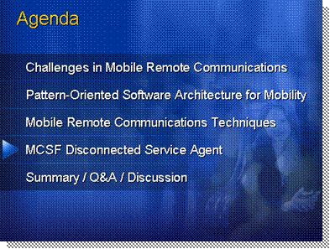
*****************************illegal for non-trainer use******************************
This section looks at the Disconnected Service Agent Application Block, which provides management features for execution of Web services from occasionally connected mobile devices.
Agenda
With a disconnected service agent, the device can maintain a queue of Web service requests when offline (disconnected) and then replay them when a connection to the server application becomes available. This means that applications can work in a disconnected environment; this is a crucial requirement in many scenarios.

Mobile Client Software Factory Components
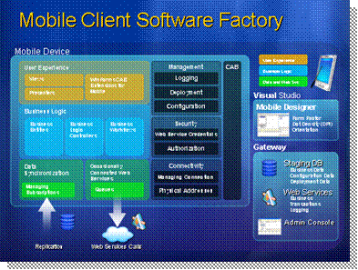
*****************************illegal for non-trainer use******************************
This diagram shows the common elements of a mobile business solution based on the Microsoft Windows Mobile operating system and a range of applications and services, as organized by the Mobile Client Software Factory. The Microsoft Windows Mobile platform, combined with the .NET Compact Framework, provide the core features required for all applications, including the tools and code libraries required to build mobile applications, and the services to provide data and integration facilities to these applications. In most cases, complex mobile solutions will integrate with a back-end ERP or CRM system or other corporate application.
Introduction
The proven techniques and code blocks developed by the patterns & practices group at Microsoft, together with code blocks, implement the services and components for applications running on the mobile client device.
The diagram also shows the actual architecture of a simple mobile application. The common elements include:
Mobile application architecture
User interface layers that consist of:
- Views. These are controls on the screen that the user can interact with.
- Presenters. These are classes that drive the views.
Business logic layers, consisting of:
- Business entities. These are classes that represent business concepts such as "Customer," "Bank Account," or "Address."
- Business logic components. These are classes that implement the majority of the business logic within the application.
- Business workflows. These drive the overall flow of control within the application.
Resource and data layers consisting of:
- Data access components. These can fetch data from a local store such as Microsoft SQL Server Mobile Edition, and they may use infrastructure components to manage data subscriptions and expirations.
- Service agents. These act as proxies to external Web services and meet the additional challenge of working in occasionally connected environments.
Building applications that follow the design and structure shown in this diagram requires infrastructure components that implement common tasks, including:
Infrastructure components
Management:
- Logging. This includes storing data about instrumentation events that can be collected on the server when connected.
- Deployment. This makes it easier to deploy applications to the device and update them as you add new functionality.
- Configuration. This includes supporting rich storage mechanisms and allowing the server to push complex data such as specific configurations per user or per device.
Security:
- Credential management. This includes storing user credentials so that calls to occasionally connected Web Services can be authenticated.
Connectivity:
- Connection and network management. This includes providing features for assessing the current connectivity of the device and reacting to changes in connectivity.
You can also simplify the application architecture and development of its internal logic by use of the container model. The Mobile Client Software Factory uses the Compact Composite UI Application Block as the basis for this container. The Composite Application Block included in the mobile project is an almost exact replica of the Composite Application Block that is available for desktop .NET applications, which means that you can take advantage of existing skills and code across both environments.
As the architect, you want to make sure that your mobile smart client applications derive from a sound, proven practice-based foundation that:
Architect scenarios
- Provides a standard approach to application development.
- Promotes re-usability of common architectural components.
- Hides complexity.
- Allows developers to focus on business problems instead of infrastructure components.
The Mobile Client Software Factory provides a starting point for creating that foundation. It provides out-of-the-box implementation of a set of features and mechanisms that are common to mobile applications. Additionally, you can customize and extended it to better fit your specific needs. You can add your patterns, How-to topics, and extend the Guidance Automation Toolkit packages to meet specific requirements for your organization.
As an application developer, you want to focus on the business logic and the user experience of your application. You want to use a baseline that provides you with the necessary infrastructure and the architecture mechanisms that you need. That baseline is the Mobile Client Software Factory modified and extended by the architect.
Developer scenarios
You will review the patterns, the How-to topics, and the reference implementation to understand the proven practices for developing smart clients. After you are ready to build your application, you will use the Guidance Automation Toolkit packages to generate items such as your initial solution, modules, and service agent.
The Mobile Client Software Factory provides the following benefits:
Benefits
- Accelerated start. It provides an effective way for architects and developers to create a high-quality starting point (baseline) for their solutions. The baseline includes code and patterns that are typically discovered in Iteration 0, or the inception and elaboration phases, of a project. This means that projects begin with a greater level of maturity than applications developed without source code or guidance.
- Reduced risk. It provides you with a proven baseline architecture. The baseline addresses the architecturally significant use cases by exposing design decisions and risks early in the development cycle.
- Increased quality. It provides reusable assets, guidance, and examples that address common smart client scenarios and challenges. The code and guidance have been tested for the target scenarios. Tests are supplied as part of the package and they can be extended and used to automatically verify changes and identify problems.
- Increased productivity. It includes automation for Visual Studio 2005. With this automation, developers can easily apply guidance in consistent and repeatable ways.
- Ease of adoption. It is open and customizable. Architects and development leads can customize the factory to meet specific needs. The factory is fully documented.
The Mobile Client Software Factory contains the following:
Factory Contents
Documentation:
- "Introduction to the Mobile Client Software Factory." This provides a vocabulary and framework that the remaining documentation uses to describe the mobile client architecture.
- "Mobile Client SF Application Blocks." This provides a thorough description of common, reusable building blocks inspired in popular desktop application blocks like the Composite UI Application Block and Enterprise Library; and other more specific ones like the Orientation Aware Control Application Block.
- "Patterns." This introduces patterns that provide solutions to common mobile client design, implementation, and deployment challenges.
- "Quick Starts Examples." Simple, introductory, step-by-step instructions to build a mobile application using the Compact Composite UI Application Block.
- "Reference Implementation." This describes the requirements, architecture, and implementation of the AdventureWorks2Go reference implementation.
Reference implementation:
- The reference implementation is an executable sample application that demonstrates the mobile client guidance in action. You can use the reference implementation to learn how the factory's deliverables are applied, or you can use it to copy code or concepts into your applications.

The reference implementation was developed as a Windows Mobile 5.0 Pocket PC application. It was not tested for Smartphone devices.
Note

Guidance package:
- The Mobile Client Development Package automates development activities that developers would usually have to manually perform frequently by following a series of instructions. It helps developers build smart client solutions in a way consistent with the architecture guidance.
The factory uses a ported version of the Composite UI Application Block to address the core Client UI patterns—such as composite, provider, event broker, and layout management. The Composite pattern combines simple user interface parts to create a complex user interface while allowing the parts to be independently developed, tested, and deployed. For more information, see the Composite UI Application Block.
Existing patterns & practices Assets
The factory also uses modified versions of Enterprise Library to address common challenges such as data access.
The toolkit uses the Guidance Automation Toolkit to automate common development tasks that simplify the development of templates and recipes. The Guidance Automation Toolkit is a lightweight Visual Studio extensibility mechanism. For more information, see the Visual Studio Team System Developer Center.
Many patterns implemented in the Mobile Client Software Factory are also available for desktop Smart Clients in the Smart Client Software Factory.
This guidance is intended for software architects and software developers. To develop using this guidance, you should have an understanding of the following technologies:
Intended Audience
- Microsoft Visual C# or Microsoft Visual Basic 2005
- Microsoft .NET Framework 2.0 and .NET Compact Framework 2.0
- Windows Forms
- Windows Mobile 5.0
- Applications built using this guidance will require the .NET Framework 2.0 to run.
The minimum requirements for satisfactory performance when developing Mobile Client applications are:
System Requirements and Installation
Using an external device:
- Windows XP or Windows Server 2003
- 1.5 GHz processor
- 512 MB memory (1 GB preferable for best performance)
- 20 MB free disk space
- Pocket PC device with 512 MB memory available
Using the Visual Studio Mobile Device Emulator:
- Windows XP or Windows Server 2003
- 1.5 GHz processor
- 1 GB memory (2 GB preferable for best performance)
- 20 MB free disk space
Before using the Mobile Client Software Factory, you must install some tools and utilities. The requirements for developing with and using the Mobile Client Software Factory are:
- Visual Studio 2005
- .NET Compact Framework 2.0
- SQL Server 2005 Mobile Edition
- Windows ActiveSync 4.1
- Windows Mobile 5.0 Pocket PC SDK
Make sure you visit the Mobile Client Software Factory page online at http://msdn.microsoft.com/practices/default.aspx?
pull=/library/en-us/dnpag2/html/mcsflp.asp for more details on these requirements and where to obtain them.

Mobile Client Software Factory Application Blocks Overview
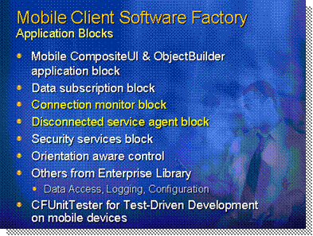
*****************************illegal for non-trainer use******************************
The application blocks in the Mobile Client Software Factory are:
Introduction
- A set of Mobile Application Blocks designed specifically to help you build mobile applications
- The Mobile CAB and Mobile Object Builder blocks that provide the core features for creating object instances, and instantiating services
The fundamental nature of mobile devices, and the kinds of application deployed to them, means that the Mobile Client Software Factory must incorporate several features that are not usually required for desktop or server applications, or which are part of the underlying desktop or server platform. To minimize the memory footprint on the mobile device, the Mobile Client Software Factory exposes these features as separate application blocks that you can install and use in any combination you require.
The application blocks provided with the Mobile Client Software Factory are:
Application Blocks
- The Data Subscription Block, which provides services required for an application that may be disconnected from the server and data source to work in offline mode.
- The Connection Monitor Block, which monitors and exposes connections between the device, and the gateway that connects it to the backend services and data sources it uses.
- The Disconnected Service Agent Block, which provides features for storing offline Web service requests, and executing them when connectivity is available.
- The Security Services Block, which provides the credentials management for connections and applications running on the mobile device.
- The Orientation Aware Control Block, which implements a control that adapts the visual UI to suit different screen resolutions, dot densities, and orientations.
A range of other application blocks are also available, based on those that are part of the desktop Enterprise Library. These consist of:
- The Data Access Block, providing features to simplify data access code requirements.
- The Logging Block, providing a reduced set of logging features appropriate to mobile devices.
- The Configuration Block, providing simplified features for managing application configuration on a mobile device.
Also included is a custom CFUnitTester framework to perform Test-Driven Development (TDD) on mobile devices with .NET Compact Framework 2.0 projects.
The rest of this section focuses only on the Disconnected Service Agent and the Connection Monitor application blocks.

Demo: Mobile Client Software Factory Disconnected Service Agent
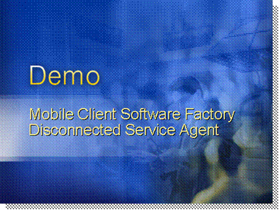
*****************************illegal for non-trainer use******************************
In this demonstration you will discover how to consume occasionally connected Web services using the Disconnected Service Agent block. We’ll also customize and extend it.
Demo
This demonstration shows how to:
- Use the Disconnected Service Agent Block.
- Implement a Disconnected Service Agent for a specific Web service.
- Extend the Disconnected Service Agent
In order to submit delivered orders to the central system, the mobile client will consume a Web service. We’ll start implementing a sample Web service. Then we will add the Web reference in the DeliveryModule, and creating the RequestManager in the shell. After that we will create a Disconnected Agent for the Web service using the Mobile Client Guidance Package and implement the callback class. Having the DSA already implemented, we can extend it to get access to the CAB services in the callback class.

This demonstration is documented here in a step-by-step format to help you prepare since it is recommended that you complete the steps a few times to get familiar with the code and procedure. Performing these steps “live” in front of your attendees might not be recommended if you have very limited time for the whole session. If your session is in “presentation” or “conference” mode, then you should walk your attendees through the completed code, showing them the highlights of how it works to save time. If your session is more “training” style and time permits, then you can walk attendees through the steps of the demonstration, but make sure you are have done so before as it is easy to make mistakes when faced with attendees who ask questions along the way.
Presenter Note

- Open Microsoft Visual Studio 2005 and go to the “File | New | Web Site” menu.
Step 1 – Creating the AdventureWorksService
- Select “ASP.NET Web Service”, change location to “HTTP” and “http://localhost/AdventureWorksService”.
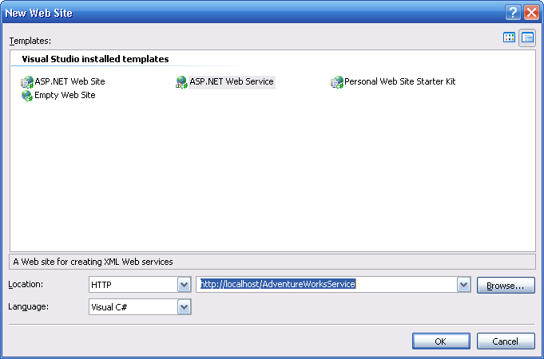
- Click “OK”.
- In the “service.cs” file replace the HelloWorld method with the following text:
C#
[WebMethod]
public void UpdateDeliveryOrderStatus(int cod_deliveryOrder, int cod_status, int cod_motive)
{

}

- Build the solution. (You can use “Control” + “Shift” + “B”).

Open the AdventureWorks.sln solution file and add a Web reference to the DeliveryService in the DeliveryModule. To get this reference you should right click the References folder in the DeliveryModule project and select “Add Web Reference”. In the “Add Web Reference” dialog click the “Web services on the local machine” hyperlink.
Step 2 – Adding the Web reference to the DeliveryModule
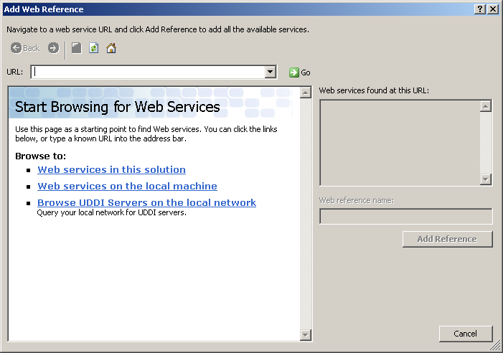
Select http://localhost/AdventureWorksService/Service.asmx and set the Web reference name as “AdventureWorksService”.
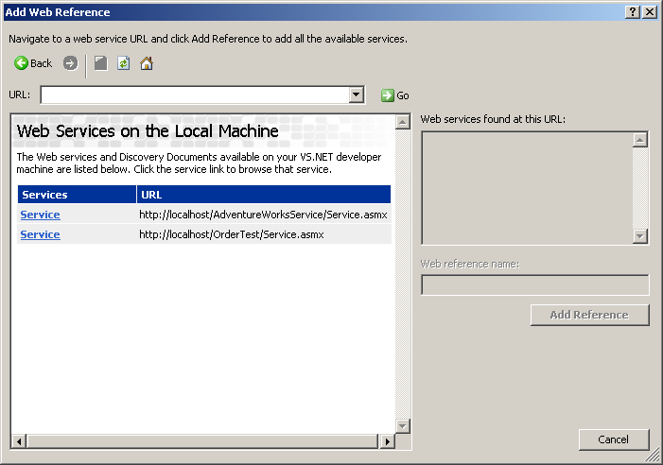
Click the “Add Reference” button.

Open the AdventureWorks project, and add a project reference to the Disconnected Agent block.
Step 3 – Adding and Starting the RequestManager service
Double click the RookWorkItemController.cs file and add the following line at the beginning of the RootWorkItemController class.
C#
using Microsoft.Practices.Mobile.DisconnectedAgent;

Add the following method in the RootWorkItemController class.
C#
private void AddRequestManagerService()
{
Database database = this.WorkItem.Services.Get<Database>();
IEndpointCatalog endpointCatalog = this.WorkItem.Services.Get<IEndpointCatalog>();
ConnectionMonitor connMonitor = this.WorkItem.Services.Get<ConnectionMonitor>();

IConnectionMonitor connections = new ConnectionMonitorAdapter(connMonitor);
RequestManager.Instance.Initialize(endpointCatalog, connections, database);
this.WorkItem.Services.Add<RequestManager>(RequestManager.Instance);
this.WorkItem.Services.Add<IRequestQueue>(RequestManager.Instance.RequestQueue);
RequestManager.Instance.StartAutomaticDispatch();
}

Replace the AddServices method with the following text in order to call the AddRequestManagerService:
C#
private void AddServices()
{
Database dbService = AddDatabaseService();
IEndpointCatalog catalog = AddEndpointCatalogService();
AddSubscriptionService(dbService, catalog);
AddConnectionMonitorService();
AddRequestManagerService();
}

In the DeliveryModule project, right click on the AdventureWorksService Web reference and select “Mobile Factory” -> “Create Disconnected Service Agent”.
Step 4 – Add the Disconnected Service Agent

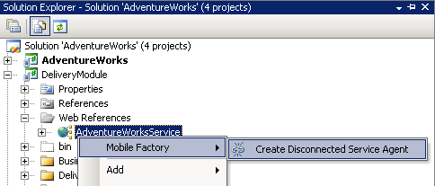
In the first step of the wizard add an Endpoint name (“AdventureEndpoint”). We’ll configure the Endpoint catalog in the App.config file later.
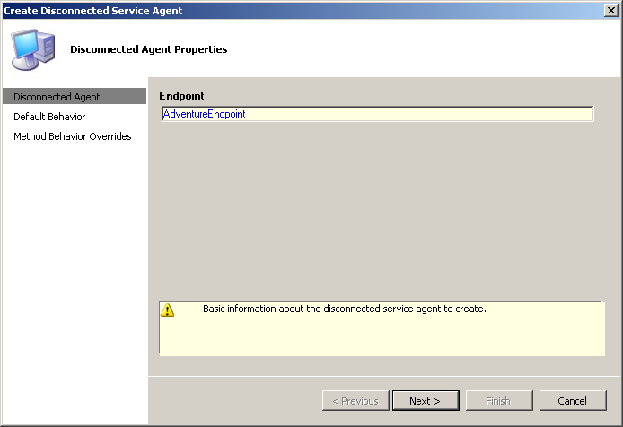

Enter the following values as the Disconnected Agent default Offline Behavior.
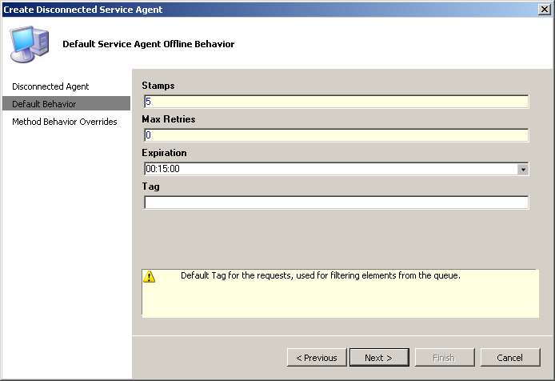

Don’t override specific method offline behavior. Just click "Finish."
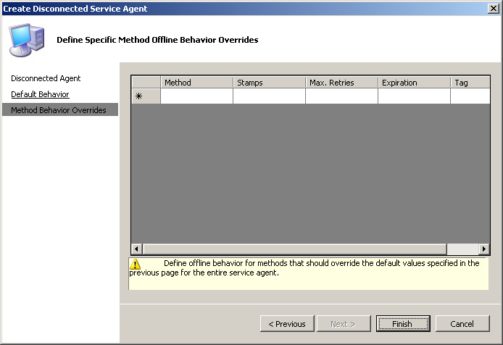
After the wizard finishes, we’ll see a new folder named ‘DisconnectedAgents” which contains a sub folder “AdventureWorksService”. In this folder we can find three files: ServiceAgent.cs, ServiceAgentCallbackBase.cs and ServiceAgentCallback.cs.
We should now configure the endpoint address and credentials for the Web service. Open the App.Config file in the AdventureWorks project and add the following line in the EndpointItems section:
XML
<add Name="AdventureEndpoint" Address="http://ppp_peer/AdventureWorksService/service.asmx" UserName="" Password=""/>

Open the DeliveryStatusPresenter.cs file (located in the DeliveryModule).
Step 5 – Using the Disconnected Agent from the Application Logic
To create the disconnected agent we need the IRequestQueue service. We will get it using Service Dependency. To do this we should start adding a new private member in the class:
C#
private IRequestQueue requestQueue;

Now we can get the corresponding service in the constructor in order to set the local variable which we’ve just added to the class. Please replace the constructor with the following code:
C#
public DeliveryStatusPresenter(
[ServiceDependency] IDeliveryRepository deliveryRepository,
[ServiceDependency] WorkItem workItem,
[Dependency]DeliveryStatusController controller,
[ServiceDependency] IRequestQueue requestQueue)
{
this.deliveryRepository = deliveryRepository;
this.workItem = workItem;
this.controller = controller;
this.currentDeliveryOrder = workItem.Items.Get<DeliveryOrder>("CurrentDeliveryOrder");
this.requestQueue = requestQueue;
}
Finally, we should implement the SendDisconnectedAgentRequest:
C#
private void SendDisconnectedAgentRequest(DeliveryOrder deliveryOrder, DeliveryOrderStatus status, DeliveryMotive motive)
{
DeliveryModule.DisconnectedAgents.AdventureWorksService.ServiceDisconnectedAgent disconnectedAgent
= new DeliveryModule.DisconnectedAgents.AdventureWorksService.ServiceDisconnectedAgent(requestQueue);
disconnectedAgent.UpdateDeliveryOrderStatus(deliveryOrder.Id, status.Code, motive.Code);
}

Open the ServiceAgentCallback.cs file located in the DeliveryModule.
Step 6 – Implementing the Callbacks class
Insert the following line at the top of the file:
C#
using System.Windows.Forms;

And replace the callbacks methods with the following text.
C#
public override void OnUpdateDeliveryOrderStatusReturn(Request request, object[] parameters)
{
MessageBox.Show("Request has been submitted. (order " + parameters[0].ToString() + ")");
}

public override OnExceptionAction OnUpdateDeliveryOrderStatusException(Request request, Exception ex)
{
MessageBox.Show("Exception: " + ex.Message);
return OnExceptionAction.Dismiss;
}

Press F5 to test the application. (The device or emulator should be connected to use Web services).

After each order submission, the application should save the submitted status of the order in the database. Logically, the right place to implement this functionality in the application is the callback method “OnUpdateDeliveryOrderStatusReturn”. The problem is that the callback object is created by the WebServiceDispatcher in the DSA out of the object builder and CAB. Due to this, we cannot use service dependency to get the database service already registered in the root work item.
Step 7 – Extending the DSA: Creating a CAB dispatcher
To avoid this limitation, we will extend the Disconnected Service Agent Block, implementing a new Dispatcher that uses CAB to create the callback object.
The first step is to create the CabRequestDispatcher class.
Right click on AdventureWorks project and select Add | Class.
Set CabRequestDispatcher as the class name. Paste the following code as the file content:
C#
using System;
using System.Collections.Generic;
using System.Text;
using Microsoft.Practices.Mobile.DisconnectedAgent;
using Microsoft.Practices.Mobile.EndpointCatalog;
using Microsoft.Practices.Mobile.CompositeUI;
using System.Net;
using System.Reflection;

namespace AdventureWorks
{
public class CabRequestDispatcher : WebServiceRequestDispatcher
{
WorkItem workItem;

public CabRequestDispatcher(IEndpointCatalog catalog, [ServiceDependency] WorkItem workItem)
: base(catalog)
{
this.workItem = workItem;
}

protected override OnExceptionAction InvokeExceptionCommand(Request request, Exception realException)
{
if (request.Behavior.ExceptionCallback != null)
{
return (OnExceptionAction)this.CabBuildCallbackInvoke(request.Behavior.ExceptionCallback, request, realException);
}
return OnExceptionAction.Dismiss;
}

protected override void InvokeReturnCommand(object onlineProxy, Request request, object result)
{
if (request.Behavior.ReturnCallback != null)
{
MethodInfo method = onlineProxy.GetType().GetMethod(request.MethodName);
if (method.ReturnType != typeof(void))
this.CabBuildCallbackInvoke(request.Behavior.ReturnCallback, request, request.CallParameters, result);
else
this.CabBuildCallbackInvoke(request.Behavior.ReturnCallback, request, request.CallParameters);
}
}

private Object CabBuildCallbackInvoke(CommandCallback callback, params object[] args)
{
object targetInstance = workItem.Items.AddNew(callback.TargetType);

try
{
MethodInfo method = callback.TargetType.GetMethod(callback.TargetMethodName);
return method.Invoke(targetInstance, args);
}
finally
{
workItem.Items.Remove(targetInstance);
}
}
}
}

This implementation overrides the InvokeExceptionCommand and InvokeReturnCommand methods to use the CabBuildCallbackInvoke method which creates a callback object using the Add method of the work item Items Collection.
Now we need to initialize the RequestManager using the CabRequestDispatcher instead of the default one. Open the “RootWorkItemController.cs” file and replace the AddRequestManagerService with the following text:
C#
private void AddRequestManagerService()
{
Database database = this.WorkItem.Services.Get<Database>();
IEndpointCatalog endpointCatalog = this.WorkItem.Services.Get<IEndpointCatalog>();
ConnectionMonitor connMonitor = this.WorkItem.Services.Get<ConnectionMonitor>();
DatabaseRequestQueue requestQueue = new DatabaseRequestQueue(database, "Requests");
DatabaseRequestQueue deadLetterQueue = new DatabaseRequestQueue(database, "Dlq");
CabRequestDispatcher dispatcher = this.WorkItem.Services.AddNew<CabRequestDispatcher, IRequestDispatcher>();

IConnectionMonitor connections = new ConnectionMonitorAdapter(connMonitor);
RequestManager requestManager = RequestManager.Instance;
requestManager.Initialize(requestQueue, deadLetterQueue, connections, dispatcher, endpointCatalog);
this.WorkItem.Services.Add<RequestManager>(requestManager);
this.WorkItem.Services.Add<IRequestQueue>(requestManager.RequestQueue);
requestManager.StartAutomaticDispatch();
}

Finally, we should replace the callbacks class to implement the functionality using the database service:
C#
using Microsoft.Practices.Mobile.DisconnectedAgent;
using System;
using Microsoft.Practices.Mobile.CompositeUI;
using System.Windows.Forms;
using Microsoft.Practices.Mobile.DataAccess;
using Microsoft.Practices.Mobile.CompositeUI.EventBroker;

namespace DeliveryModule.DisconnectedAgents.AdventureWorksService
{
// Generated code for the Web service.
// Use this proxy to make requests to the service when working in an application that is occasionally connected
public class ServiceDisconnectedAgentCallback
{
private IDeliveryRepository deliveryRepository;

[EventPublication("http://AdventureWorks/IsDisconectedServiceAgentSubmited", PublicationScope.Global)]
public event EventHandler IsDisconectedServiceAgentSubmited;

public ServiceDisconnectedAgentCallback ([ServiceDependency] Database database)
{
deliveryRepository = new DeliveryRepository(database);
}

public void OnUpdateDeliveryOrderStatusReturn(Request request, object[] parameters)
{
MessageBox.Show("Request has been submitted. (order " + parameters[0].ToString() + ")");

int cod_deliveryOrder = (int)parameters[0];
this.deliveryRepository.UpdateIsDisconnectedServiceAgentSubmited(cod_deliveryOrder);
OnIsDisconectedServiceAgentSubmited(EventArgs.Empty);

}

public OnExceptionAction OnUpdateDeliveryOrderStatusException(Request request, Exception ex)
{
MessageBox.Show("Exception: " + ex.Message);
return OnExceptionAction.Dismiss;
}

public void OnIsDisconectedServiceAgentSubmited(EventArgs e)
{
if (IsDisconectedServiceAgentSubmited != null)
IsDisconectedServiceAgentSubmited(this, e);
}
}
}

Press F5 to test the application.

Disconnected Service Agent
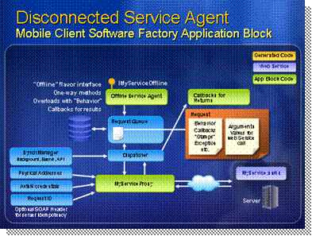
*****************************illegal for non-trainer use******************************
Web services rely on established Internet standards such as HTTP, XML, and SOAP for the required application interoperability. A client can communicate with a Web service as long as the client is running on a platform that supports these industry-wide Internet standards, but also as long as the client device has connectivity to the server hosting the Web service. What happens if no wireless signal is available or the device is currently disconnected from any wireless network?
Introduction
The Disconnected Service Agent Block provides management features for execution of occasionally connected Web services. This allows the device to maintain a queue of Web service requests when offline (disconnected), and then replay them when a connection to the server application becomes available. This allows the application to work in a disconnected environment - a crucial requirement in many scenarios.
Disconnected Service Agent Block
There are two distinct sections in the Disconnected Service Agent Block:
- A subsystem that allows developers to invoke disconnected Web services using patterns similar to those they are familiar with from using Visual Studio Web Services Proxies. However, the Service Agent queues requests and keeps track of the asynchronous callbacks that the application expects to receive when the Web service responds.
- A Dispatcher that determines exactly when to dispatch each call to a Web service, depending on connectivity conditions, pricing policies, and configuration settings. When the correct conditions occur, the dispatcher makes the request, using the appropriate credentials and addresses for the endpoint.
The Connection Monitor Block provides features that assist the application to perform a range of tasks related to managing connections from the mobile device to network resources. The features of the Connection Monitor Block include:
Connection Monitor Block
- Connection Enumeration. Applications can enumerate all of the connection types registered for the device, irrespective of whether they are currently connected. By default, there are three basic Windows Mobile 5.0 connection types: WiFi, GPRS, and DTPT. Other supported connection types are EDGE, EVDO, Roaming, and 1x. Applications can also determine if a specific connection type is available at present, and get the list of the connection types that are currently available.
- Network Enumeration. Applications can enumerate all of the networks available on the device. Applications can also determine if a specific network is available at present.
- Pricing. Administrators can associate a "price" or "cost" with each type of connection, using a series of whole number values. Applications can retrieve this value for a specific connection type. This allows the device to choose the appropriate connection method when more than one is available. Simple syntax such as Connections["EDGE"].Price and CurrentConnectionPrice() makes it easy to work with this feature.
- Network Connectivity. Provides an indication of current connectivity by raising events that the application can subscribe to so that it receives notification when the network connection status changes. This allows applications to detect connection and disconnection (without being concerned about signal strength), and display status messages such as "Connected to: Internet". Supports methods such as Connect() and Disconnect() for a network, and the ability to perform connection tests using the Ping method, for example: Networks["Internet"].Ping.DoPing().
In future releases, the Connection Monitor Block may contain:
- SMS Message Service. This allows the device to communicate using the text-based Short Message Service (SMS) available on most telephone-provider networks. The SMS Message Service allows commands sent to the device to carry out actions programmatically; for example, notifying of application updates, causing data synchronization or a device wipe.
The Disconnected Service Agent Application Block exposes several core classes that you work with when using the services provided by this application block:
- The RequestManager class manages the request queues and uses the services of the WebServiceRequestDispatcher class to dispatch these requests. It stores the queues of pending and failed requests in the SQL Server 2005 Mobile Edition (SQL Server Mobile) database on the device using the DatabaseRequestQueue class or a custom implementation of the IRequestQueue interface.
- The Request class is the store for a Web service request, including the arguments or parameters required by the Web service method, the endpoint for delivery of the request, and properties that specify how the dispatcher should handle and deliver the request. The EndpointCatalog class exposes all known endpoints from the application's configuration file.
- The ConnectionMonitorAdapter class provides information about the connection used by the request, such as the price and network details, and it raises events when status of the connection changes. As the "Adapter" part of the name suggests, it sits between the RequestManager and the ConnectionMonitor.
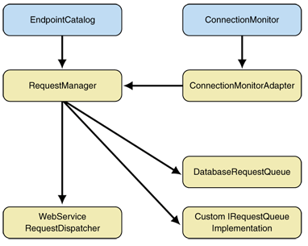
The Disconnected Service Agent Application Block uses services from the Connection Monitor Application Block to get information about the connections available on the device, the Data Access Application Block to manipulate the local SQL Server Mobile database where it stores pending and failed requests, and the Endpoint Catalog Application Block to manage endpoints. For details about the application blocks, see the related guidance for them.

Connection Monitor
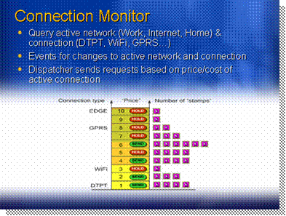
*****************************illegal for non-trainer use******************************
The Connection Monitor Application Block monitors and exposes the available connections and the associated networks through which the device can connect to a gateway that provides the back-end services and data it uses. The Connection Monitor Application Block provides the following features:
Introduction
- Connection enumeration. This feature enumerates all the connection types registered for the device, irrespective of whether they are currently connected.
- Network enumeration. This feature enumerates all the networks available to for the device, irrespective of whether they are currently connected.
- Network connectivity. This feature provides an indication of current connectivity by raising events that the application can subscribe to so that it receives notification when the network connection status changes.
- Pricing. This feature associates a cost with each type of connection, using whole number values. Applications can choose the appropriate connection type to send messages to the server, or they can prioritize message delivery based on the connection type.
The Connection Monitor Application Block provides the interface between your applications and the connectivity features of the mobile device on which it runs. Several other features of the Mobile Client Software Factory depend on the services of the Connection Monitor Application Block; in particular, the Disconnected Agent Application Block.
Connection Monitor Components
The key component at the heart of the Connection Monitor Application Block is a single instance (singleton) class named ConnectionMonitor, which exposes keyed collections of Connection and Network instances that represent the currently configured connections and the available networks for the device. It also exposes details of the active connection and network, and it raises the ActiveNetworkChanged event when the device changes to a different connection type or when it connects to or disconnects from a network.
Because the .NET Compact Framework does not provide suitable APIs, the ConnectionMonitor relies on another class, named ConnectionMonitorNativeHelper, which calls native (unmanaged) methods within the Windows Mobile operating system to obtain the information it requires.
To simplify creation of ConnectionMonitorservice instances, the Connection Monitor Application Block includes a factory class named ConnectionMonitorFactory that exposes a static CreateFromConfiguration method. This method takes a String value that specifies the name of the section in the application configuration file that contains the list of connections and connection prices; it creates and populates the ConnectionMonitor instance. You can also omit the section name, in which case it uses the default section name "Connections."
Applications that use the Mobile Client Software Factory do not always have to know the connectivity status of the device. The use of a request queuing system for remote Web service requests, as implemented by the Disconnected Service Agent, means that in most situations the application can just queue requests and handle the callbacks raised when the request succeeds or fails, when the appropriate connection type is (or becomes) available.
Connectivity
However, there are situations where the application or user may want to submit a request, or refresh the stored reference data, on demand. The AdventureWorks2Go reference implementation uses this feature to force dispatch of requests when the user clicks the appropriate button in the application. In this case, the application can check for connectivity using the ActiveConnection and ActiveNetwork properties of the Connection Monitor. Both of these are null when there is no connectivity.
In other cases, the application may display a list of configured connections, indicating the status of each one, and even allow the user to query for more information on a specific connection. This is another feature implemented within the AdventureWorks2Go reference implementation. Alternatively, the application may just display the current network name, or even an icon or indicator showing connection status, at the bottom of the screen. For these tasks, the StateChanged events of the Connection and Network classes, and the ActiveNetworkChanged event of the ConnectionMonitor class, allow applications to react to, and display details of, connectivity changes.
Code in the Mobile application blocks has knowledge of the relative "cost" or "price" of a connection (depending on the connection type, as stored in the application configuration). You can also specify the relative "importance" or "stamps" value of each request when creating that request. The dispatcher service then uses all this information to determine when, and over which connection type, it will dispatch each request.
Pricing
The Connection class exposes a property named Price that specifies the cost of each connection as a whole number. This means that your application can query or change the cost of each connection and allow users to manually control dispatching with full knowledge of the cost implications incurred.

Physical Addresses
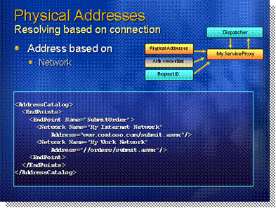
*****************************illegal for non-trainer use******************************
Mobile device applications must be able to make requests to remote Web services to push data updates from the device to the server. The Disconnected Service Agent Application Block uses the Endpoint Catalog Application Block described here to manage the lists of physical addresses and other details for each connection point.
Introduction
The Endpoint Catalog Application Block is a simple service that uses a dictionary to store individual endpoints and the associated credential for each endpoint. An endpoint consists of a name and a series of network names appropriate for that endpoint. A credential consists of two or three String values: a user name, a password, and optionally a logon domain name.
Endpoint Catalog Application Block
The EndpointCatalog class (the main class in the Endpoint Catalog Application Block) uses the Dictionary class to store and expose a series of individual Endpoint instances, keyed on the name of the endpoint.
To populate the Dictionary with the endpoint information stored in the application configuration file, the user calls the CreateCatalog method of the EndpointCatalogFactory class. The CreateCatalog method uses the configuration classes in the Configuration subfolder of the Endpoint Catalog Application Block to access the configuration section that contains the stored configuration information.
The following XML shows a typical <Endpoints> configuration section in an App.config file (with placeholder values for the various attributes). An endpoint consists of a name, optionally a default URL (address) and credential, and a series of child network items. Each network item provides a name, a URL (address), and the credential for connecting to the endpoint over this network.
The disconnected service agent mechanism supports unique message IDs for each request it makes to remote servers and Web services. The message IDs are GUIDs that allow the service to identify requests and guard against replay attacks.
Web service Idempotency and WS-Addressing
The WS-Addressing recommendation specifies how a Web service should implement idempotency for requests through unique message IDs and the format for the SOAP headers that contain these IDs. By conforming to the current WS-Addressing recommendation, your Web services will also be compatible with forthcoming versions of the WS recommendations (WS3) and Windows Communication Foundation (WCF, formerly known as "Indigo") Web service specifications.
There are four main stages in implementing custom headers in Web service SOAP packages that conform to WS-Addressing recommendations and ensure idempotency for requests:
- On the server, in your Web service, define the MessageIDSoapHeader for the package.
- On the server, specify that your Web service can accept that header.
- On the client, add the header value to the Web service proxy (the Mobile Client disconnected service agent has a default Web service dispatcher that automatically does this).
- On the server, use the header value in the Web service to help determine whether this is a duplicate request.
The Mobile Client Software Factory guidance documentation describes these four stages in detail.

Credentials
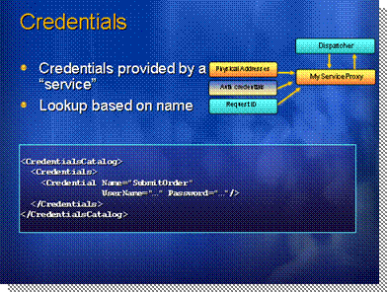
*****************************illegal for non-trainer use******************************
Almost all the Web service requests you make will be to resources that require user authentication. In other words, the request must specify details of an account registered on the server that has the permissions required to fulfill the request.
Introduction
The most common authentication method is the use of a user name and password, and optionally a domain within which the server should validate the account details (usually the domain where the account resides). The combination of the user name, password, and (optionally) the domain is a credential. The Endpoint Catalog Application Block stores and exposes to applications the credentials for each endpoint.
Authentication method

Demo: Disconnected Service Agent & Connection Monitor
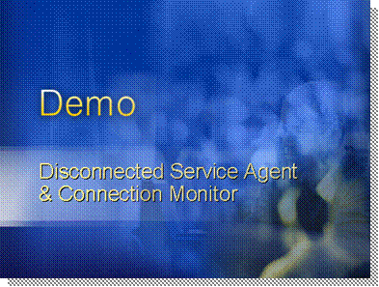
*****************************illegal for non-trainer use******************************
During this lab you will develop the logic to process data on the device, and you will learn how to integrate connection monitoring and loosely coupled eventing in your application.
Introduction
In this exercise, we will modify the DeliveryModule to provide the delivery orders processing functionality to our burgeoning application. We will first add the domain model classes that will be used to manipulate the data, as well as a Repository class which will be responsible for talking to the underlying database using the Data Access Application Block.
We will then use the now familiar MVP pattern to create the views and presenters required to fulfill the use cases.
Once we have the UI in place, we will deviate a little bit from the main use case (manipulation of delivery orders) and will add functionality to the application that will use the Connection Monitor Application Block to detect connectivity and show that information in the About form. We will also use loosely coupled events through the CAB Event Broker to publish the connection status to a new status bar control we will add to the main form. This will show how components in different modules or assemblies can communicate with each other without having any dependency between them.
The module will expose its functionality through a new Launch Item, and therefore will have a reference to the AdventureWorks shell project that provides that functionality.
Right click on the “Source” folder, and select Mobile Factory | Composite UI Module. Set the name to “deliveryModule” and click the “Ok” button.
Step 1 – Add a Module named “DeliveryModule”
Verify deploy check box for deliveryModule is checked. To do this, right click on the Solution and select properties. In the solution property page select “Configuration Properties” and verify DeliveryModule has the deploy check box checked.
Add the following project references to the DeliveryModule project:
Mobile.CompositeUI.Common
Mobile.EndpointCatalog
Mobile.ConnectionMonitor
Mobile.DataAccess
AdventureWorks
Step 2 – Add Module initialization code
In order to see how to detect when connection is available we will subscribe to ActiveNetworkChanged event from Connection Monitor and raise an event using EventBroker (EventPublication attribute).
In DeliveryModule project, double click the ModuleInitialize.cs file and copy the following code.
Step 3 – Detecting Available Connection using the Connection Monitor
C#
using System;
using Microsoft.Practices.Mobile.CompositeUI;
using System.Windows.Forms;
using Microsoft.Practices.Mobile.CompositeUI.Commands;
using Microsoft.Practices.Mobile.CompositeUI.WinForms;
using Microsoft.Practices.Mobile.CompositeUI.Common;
using DeliveryModule.DeliveryWorkItems.DeliveryList;
using AdventureWorks.Launcher;
using Microsoft.Practices.Mobile.ConnectionMonitor;
using Microsoft.Practices.Mobile.CompositeUI.EventBroker;
using AdventureWorks;

namespace DeliveryModule
{
public class ModuleInitializer : ModuleInit
{
WorkItem workItem;
LaunchItemsCatalog launchItemsCatalog;
ConnectionMonitor monitor;

public ModuleInitializer([ServiceDependency]WorkItem workItem)
{
this.workItem = workItem;
}

public override void Load()
{
base.Load();
Initialize();
}

[ServiceDependency]
public LaunchItemsCatalog LaunchItemsCatalog
{
set { launchItemsCatalog = value; }
}

private void Initialize()
{
//Create Order launch item
//LaunchItem launchItem = new LaunchItem("Delivery Orders List", typeof(ControlledWorkItem<DeliveryListController>));
//launchItem.Image = Properties.Resources.Image1;
//launchItemsCatalog.Add(launchItem);

AddSubscribeConnectionMonitorMenuItem();
}

private void AddSubscribeConnectionMonitorMenuItem()
{
MenuItem SubscribeMenuItem = new MenuItem();
SubscribeMenuItem.Text = "Subscribe Monitor";
workItem.RootWorkItem.UIExtensionSites["uie://shell/menu/file"].Add<MenuItem>(SubscribeMenuItem);

// Invokers cause commands to execute when the given event is
// raised. Next line shows how to hook together the UI
// element with the command invocation, again in a decoupled way.
workItem.RootWorkItem.Commands["SubscribeMonitor"].AddInvoker(SubscribeMenuItem, "Click");

}

[CommandHandler("SubscribeMonitor")]
public void SubscribeMonitor(object sender, EventArgs e)
{
AttachConnectionMonitor();
}

void AttachConnectionMonitor()
{
if (monitor == null)
{
monitor = this.workItem.Services.Get<ConnectionMonitor>();
monitor.ActiveNetworkChanged += OnActiveNetworkChanged;
OnStatusTextUpdate("Connection Monitor subscribed");
}
}

private void OnActiveNetworkChanged(object sender, ActiveNetworkChangedEventArgs args)
{
string statusText = (args.Active)?"Connected":"Disconnected";
OnStatusTextUpdate(statusText);
}

//TODO: add Event Publication
[EventPublication("topic://AW/statusupdate", PublicationScope.Global)]
public event EventHandler UpdateStatusTextEvent;

protected virtual void OnStatusTextUpdate(string newText)
{
if (UpdateStatusTextEvent != null)
{
UpdateStatusTextEvent(this, new TextEventArgs(newText));
}
}
}
}
We need to define TextEventArgs. Right click the AdventureWorks project and add a new class file and copy the following code.
C#
using System;
using System.Collections.Generic;
using System.Text;

namespace AdventureWorks
{
public class TextEventArgs : EventArgs
{
private string text;

public TextEventArgs(string text)
{
this.text = text;
}

public string Text
{
get { return text; }
}
}

}

We will add a status bar to showing when the connection is available or isn’t.
We will subscribe to the event created in the previous step using EventBroker. (EventSubscription attribute).
Step 4 – Showing Connection Status in the status bar
In the AdventureWorks project, open Launcher folder and double click on LauncherView.cs and drag a StatusBar control from the ToolBox.
Set the following properties:
name: “mainStatus”
Text: “” (blank text)
Right click on the LauncherView.cs file and select “Code View”. Paste the following code in order to subscribe to event.
C#
[EventSubscription("topic://AW/statusupdate", Thread = ThreadOption.UserInterface)]
public void OnStatusUpdate(object sender, EventArgs args)
{
TextEventArgs textArgs = args as TextEventArgs;
if (args != null)
{
this.mainStatus.Text = textArgs.Text;
}
}
Press F5 to run the application. When you cradle the Pocket PC, the status bar will change to “Connected”. When you uncradle the Pocket PC, the status will change to “Disconnected”.

Summary / Q&A / Discussion
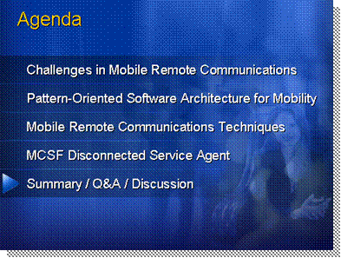
*****************************illegal for non-trainer use******************************
The final summary of the session, followed by the Q&A and discussion with attendees is presented next.
Agenda

Summary
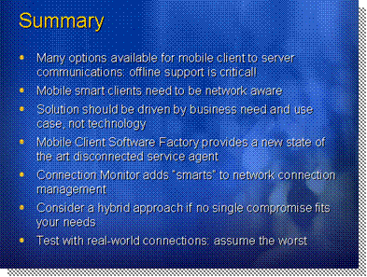
*****************************illegal for non-trainer use******************************
This session presented an overview of the primary remoting techniques that can be used to communicate and exchange data between a mobile device and a corporate server. All mobile smart clients need to support both online and offline capabilities as wireless connectivity cannot be relied on all the time. This is done through network awareness where the application monitors its connectivity status transparently from the user.
Summary
No matter what option is used, many variables like the nature of the data, the nature of the connectivity, the frequency of changes and the number of users sharing the same data centrally can affect which communication method is used. In any case, “how” users consume the data and their usage patterns should be the primary driving force behind the solution that is adopted.
The Mobile Client Software Factory (SF) from the Microsoft patterns & practices (p&p) group makes it easier to create complex mobile applications that integrate with existing systems, and reduces development time and cost. It takes advantage of best practice techniques and proven code blocks originally developed for desktop and server platforms, and provide the same features for mobile clients such as the Pocket PC. This guidance contains architectural overviews, scenarios for, and descriptions of the Mobile Client Software Factory, including the device-specific services it implements and the disconnected service agent, which provides management features for execution of Web services from occasionally connected mobile devices. The Connection Monitor Application Block monitors and exposes the available connections and the associated networks through which the device can connect to a gateway that provides the back-end services and data it uses.
Remember that ultimately, mobile smart client applications for the enterprise should always be tested on the same type of connection that users will employ on a daily basis. Using this “worst case scenario”, architects and developers can better anticipate how the remote communications will behave in production.

